Steam Project

Tissue Response to Injury

Oliver Kiech

https://humanap.community.uaf.edu/2024/07/21/tissue-response-to-injury/

For my steam project objective, I picked: Explain the role of the lymphatic system in the immune response. I have made a replica of the tissue’s response to injury for a wound to heal. More specifically, my project is a 3-dimensional cube collage of the stages the body initiates when it incurs a wound and begins in the healing response. The stages are hemostasis, Inflammation, proliferation, and remodeling.

Our skin is part of the integumentary system and is the largest organ in the body. Skin, which is made up of water, protein, fats and minerals, serves as our primary protection from injury. There are three layers of the skin, epidermis, dermis and hypodermis.  When our skin incurs an incised wound the body kicks in response to initiate healing. There are distinct stages of healing that also can be overlapping, but all of which I focus on to complete the STEAM project.

The role of the lymphatic system plays a leading role in the immune response. My STEAM project shows how the lymphatic system works with the healing and restoration of tissue function. Our body’s skin serves as the first line of defense against outside dangers.

The first response when the body receives a wound from a nail is hemostasis. Hemostasis occurs to stop the bleeding. Platelets form a clot and blood flow reduces from blood vessels constricting. “The fibrin clot ceases blood flow and provides a scaffold for incoming inflammatory cells. Neutrophils are immediately recruited to the clot as a first line of defense against bacteria. Monocytes are recruited within 48 to 96 hours after an injury and transform into tissue-activated macrophages at the wound site.” (1)

For the second immune response, inflammation occurs. Inflammation is the most important mechanism in our innate defense system. “During inflammation neutrophils arrive and engulf the bacteria along with any dead tissue, forming the pus seen in wounds after the first 48 to 72 hour. Next, monocytes become macrophages and debride the wound further, clearing the matrix and other cell debris such as fibrin and spent neutrophils. Macrophages are also responsible for releasing most of the inflammatory cytokines such as transforming growth factor-beta, platelet-derived growth factor, fibroblast growth factor and epidermal growth factor.” (2)

Another important step during inflammation is phagocyte mobilization. Neutrophils flood the area first with macrophages following. “Neutrophils are recruited to the area within 24 to 48 hours and stay for 2 to 5 days. They initiate phagocytosis which is continued by macrophages later. These phagocytic cells release reactive oxygen species and proteases for killing local bacteria and debriding necrotic tissues.” (3)

Starting from the bone marrow, leukocytosis occurs by neutrophils entering the blood. Neutrophils then cling to a capillary wall called margination. Neutrophils flatten and squeeze out of capillaries during diapedesis. Lastly neutrophils follow a chemical trail during chemotaxis.

The third response consists of Proliferation which is a step that rebuilds tissue structure by filling and covering the wound, called epithelization. In this step, fibroblasts enter the wound site for tissue repair. The wound is filled with connective tissues, margins contract and pull towards the center of the wound. This phase lasts for 4 to 24 days.

The remodeling phase is the fourth and last phase for the role of the lymphatic system healing a wound. In this phase, new tissue gets stronger and gains flexibility. Collagen fibers also reorganize, and the tissue remodels increasing strength. This phase can last anywhere from 21 days to 2 years depending on the wound severity and the individual.

The wound healing process is greatly affected by the role of the lymphatic system. During the wound healing process, vasodilation occurs causing hyperemia which leads to redness and heat. This is a good thing due to increasing blood flow to the damaged cells and tissues. Increased capillary permeability causes fluid containing clotting factors and antibodies to leak into tissue which causes swelling or edema. Edema benefits us by a surge of fluid in tissues that sweeps foreign material into lymphatic vessels for processing in lymph nodes. Edema also helps by delivering clotting proteins and complementing proteins to the area.

The lymphatic system plays a crucial role in the healing process but can also be susceptible to interruption. Factors such as moisture, infection, age, nutrition, body type, can all be factors in healing. When all the processes of our bodies lymphatic system work correctly, the outcome is a good recovery.

References

Maynard, J. (2021, December 13). *How wounds heal: The 4 main phases of wound healing*. Shield HealthCare. https://www.shieldhealthcare.com/community/popular/2015/12/18/how-wounds-heal-the-4-main-phases-of-wound-healing/

Grubbs, H. (2023, May 16). *Wound physiology*. StatPearls. https://www.ncbi.nlm.nih.gov/books/NBK518964/

Wound healing: A cellular perspective | physiological reviews. (n.d.). https://journals.physiology.org/doi/full/10.1152/physrev.00067.2017

Key

Pink beads = epidermis

White beads = white blood cells

Red = blood and wound healing/inflammation

Yellow = fat layer

Orange = blood vessel

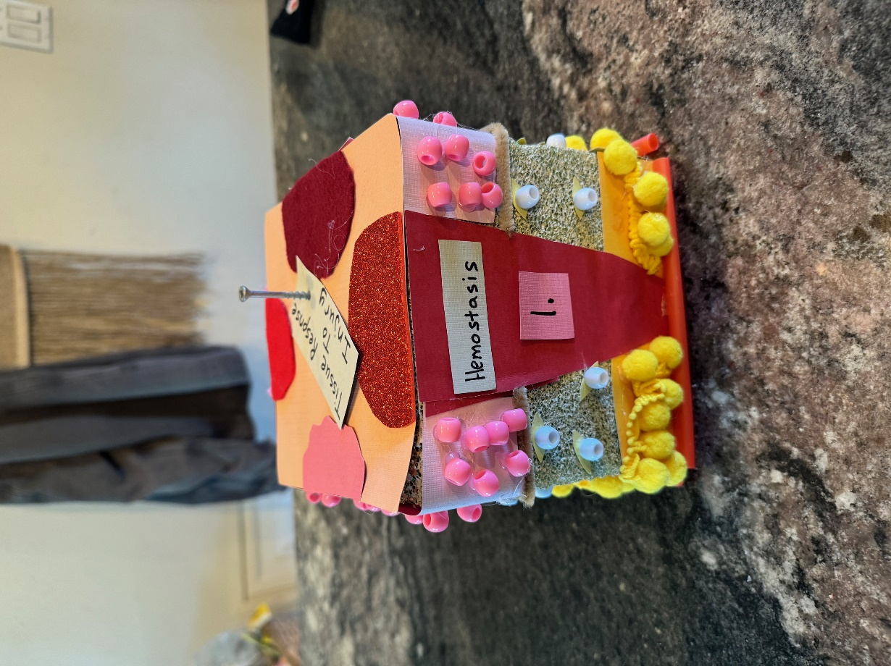

Hemostasis with neutrophils and macrophages present.

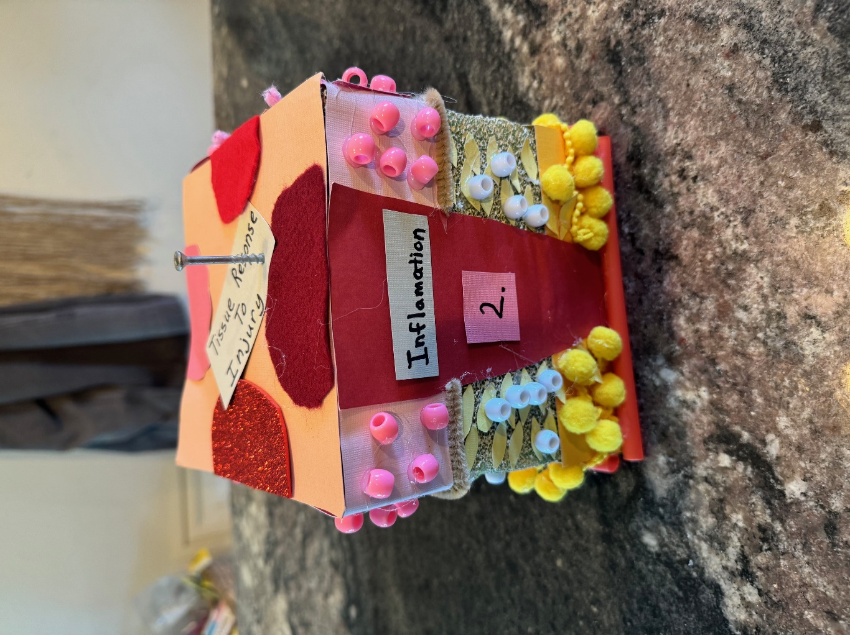

Inflamation with neutrophils and macrophages moved together.

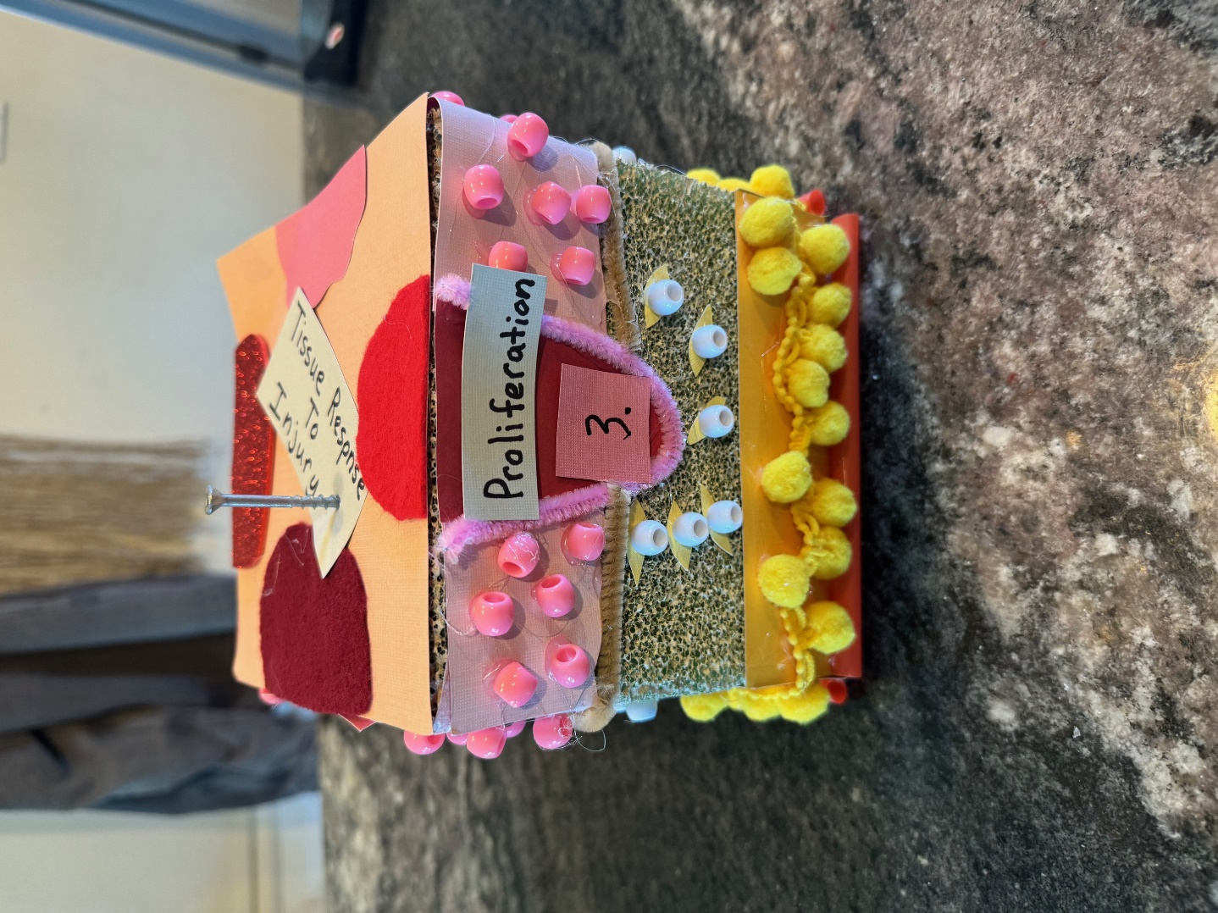

Proliferation with fibroblasts, the wound filling, and margins contracting.

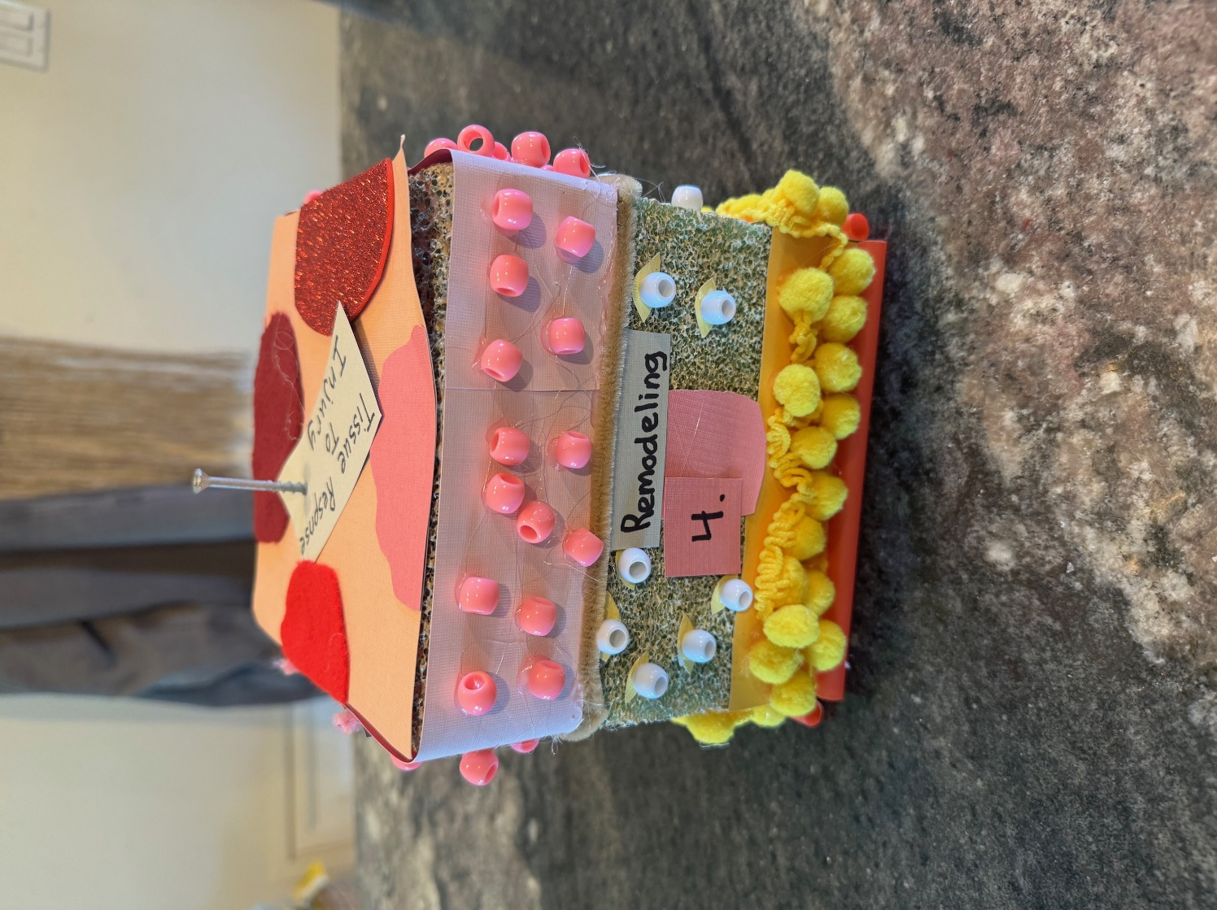

Remodeling with fibers being reorganized.

