STEAM Project

BY: OLIVER KIECH

ANATOMY AND PHYSIOLOGY 101

**Introduction – Pizza Mitosis**

The learning objective that I plan to do my STEAM project on is “describe the stages of mitosis” through a cooking project, while also learning how to make a killer pizza crust of my mothers’ own recipe. I am researching mitosis and how it looks in each stage. While going further, I will compare normal and abnormal mitosis (i.e., colorectal cancer) and show a pizza image of mitosis failing to replicate correctly.

This cooking steam project will cover our course unit 2, Macromolecules and the Cell, and in specific, the learning objective: Describe the stages of mitosis. By doing this steam project it will show a greater understanding of how mitosis can be symbolized with ingredients found on a pizza. Mitosis is the process of nuclear division in which the chromosomes are distributed to two daughter nuclei and is important for normal cell division, and this is when mitosis begins. Mitosis is a crucial step to growth of healthy tissues and bone remodeling, development of embryos, fixing and replacing damaged cells, and ultimately for sustaining our healthy bodies. The process of mitosis has 4 distinct stages: prophase, metaphase, anaphase, and telophase.

**Stages of Mitosis**

**Interphase:** Prior to mitosis is interphase where the cell prepares itself for mitosis. During interphase, the cell makes an exact copy of itself to allow for cell the divide. Interphase is represented by photo one, with a pizza cell creation.

**Prophase:** The first stage of mitosis is prophase where chromatids are present. Chromatids are identical and make up chromosomes. Centrioles are organelles present in the cell and are a crucial part of cell division. Centrioles help to organize cells, replicate the DNA, and move the chromatids to opposite ends of the cell. Nuclear envelope begins to break apart. In Figure 2, the chromosomes represented on the pizza cell are identical bell peppers (sister chromatids).

**Metaphase:** The second stage of mitosis is metaphase. During metaphase, chromosomes come together in the middle of the cell and are moved by spindles. The peppers on the pizza cell on Figure 3 line up in the middle and the spindles are represented by spaghetti and attached to each chromatid.

**Anaphase:** The third stage of mitosis is anaphase where the spindle pulls the identical chromatids to opposite ends of the cell. In Figure 4, the spaghetti spindles pull apart the identical chromatid peppers to the opposite ends of the pizza cell.

**Telophase:** The fourth stage of mitosis is telophase. Telophase can be broken into two phases. The beginning being where chromosomes loosen and form chromatin and spindles dissolve. This is important because the DNA can be more easily replicated. At the same time, a nuclear envelope develops around each identical set of chromosomes. At the end of telophase, there are two identical nuclei present. In Figure 5 two nuclear envelope pepperoni forms around the bell pepper chromosomes.

**Cytokinesis:** Post mitosis and sometimes during telophase the cell splits into two new identical cells. One of the nuclei formed in telophase is now present in each brand-new cell. In Figure 6 there are two new separate pizza cells containing the same exact bell pepper DNA.

**Abnormal Mitosis**

As further study of mitosis, I will be creating a pizza showing the abnormal process of mitosis resulting in colorectal cancer. For a healthy cell to succeed in mitosis a lot of things need to go right. There are many points where mitosis can be disrupted which leads to unequal segregations of chromosomes (chromosomal instability). Many colorectal tumors develop in this way. In colon cancer, cells lining your colon and rectum keep growing and dividing even when they’re supposed to die. (Cleveland Clinic, 2022) Colorectal tumors are also a leading cause of cancer related deaths.

Mitotic checkpoint deficiencies are when a cell does not properly progress to the next phase before the prior phase has been completed and can directly contribute to abnormal mitosis. One example of this is chromosomal instability. Chromosomal instability can take place during the different phases of mitosis. Damage from instability can become cancerous, cells continue to divide, and form a tumor. In addition, cancer cells grow to invade and destroy normal tissue nearby as well as traveling to other parts of the body.

Some other factors that play a role in colon cancer are diabetes, obesity, smoking and alcohol abuse, genetics, low-fiber, or high-fat diet, and even radiation therapy when being treated for other cancers. (Mayo Clinic, 2022). People with an average risk of colon cancer should begin screening around the age of 45 but people with an increased risk should begin sooner. Some steps to reduce a person’s risk of developing colon cancer include eating fruits, vegetables, and whole grains, reducing alcohol intake, stop smoking, exercise, and maintaining a healthy weight.

In unhealthy mitosis, the mitotic spindle fails to divide chromosomes correctly. During this, there are an abnormal number of chromosomes and are not in correct order or location. Colon cancer is just one possible result of abnormal mitosis, along with many others. In Figure 7, one pizza cell displays abnormal mitosis contrasted by a normal pizza cell. The bell pepper chromosomes are random and not identical much like in a cancer cell.

**Pizza Creation**

I will be making a pizza for our medium, providing a hands-on model of mitosis, while also creating a pizza to demonstrate colon cancer (abnormal mitosis).

Some of our cell model ingredients will include:

* Pizza crust will represent the cell membrane.
* Pizza sauce will represent the cytoplasm.
* Different colored peppers will represent organelles during mitosis.
* Pepperonis will be the contractile rings.

I will write about what happens during each stage of mitosis, while demonstrating when mitosis is abnormal. My project will be taking photos of each stage.

**Humanap Link**

https://humanap.community.uaf.edu/2023/07/23/ok-steam-project-pizza-mitosis/

**REFERENCES**

Mayo Clinic Staff. Colon Cancer. <https://www.mayoclinic.org/diseases-conditions/colon-cancer/symptoms-causes/syc-20353669> 2022.

Cleveland Clinic. (2022). Colorectal (Colon) Cancer. Retrieved July 29, 2023, from https://my.clevelandclinic.org/health/diseases/14501-colorectal-colon-cancer

Class Notes

Unit 2 Macromolocules and Cells Slide 43

Unit 2 Macromolocules and Cells Slide 44

Unit 2 Macromolocules and Cells Slide 46

Unit 2 Macromolocules and Cells Slide 49

Figure 1

Figure 2 Prophase

Figure 3 Metaphase

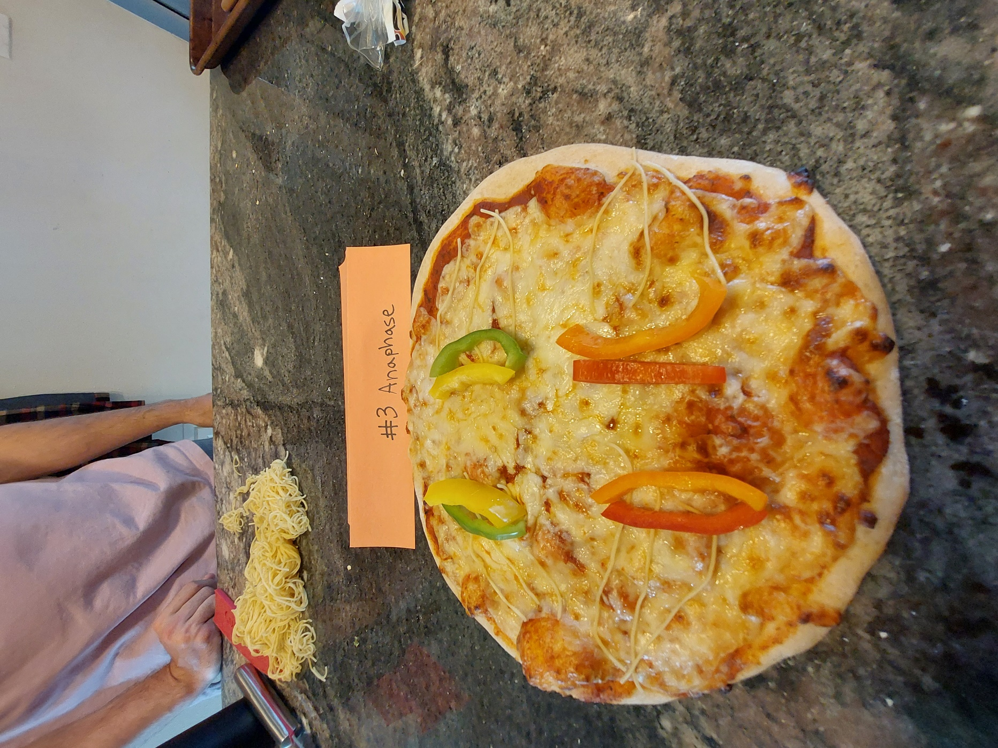

Figure 4 Anaphase

Figure 5 Telophase

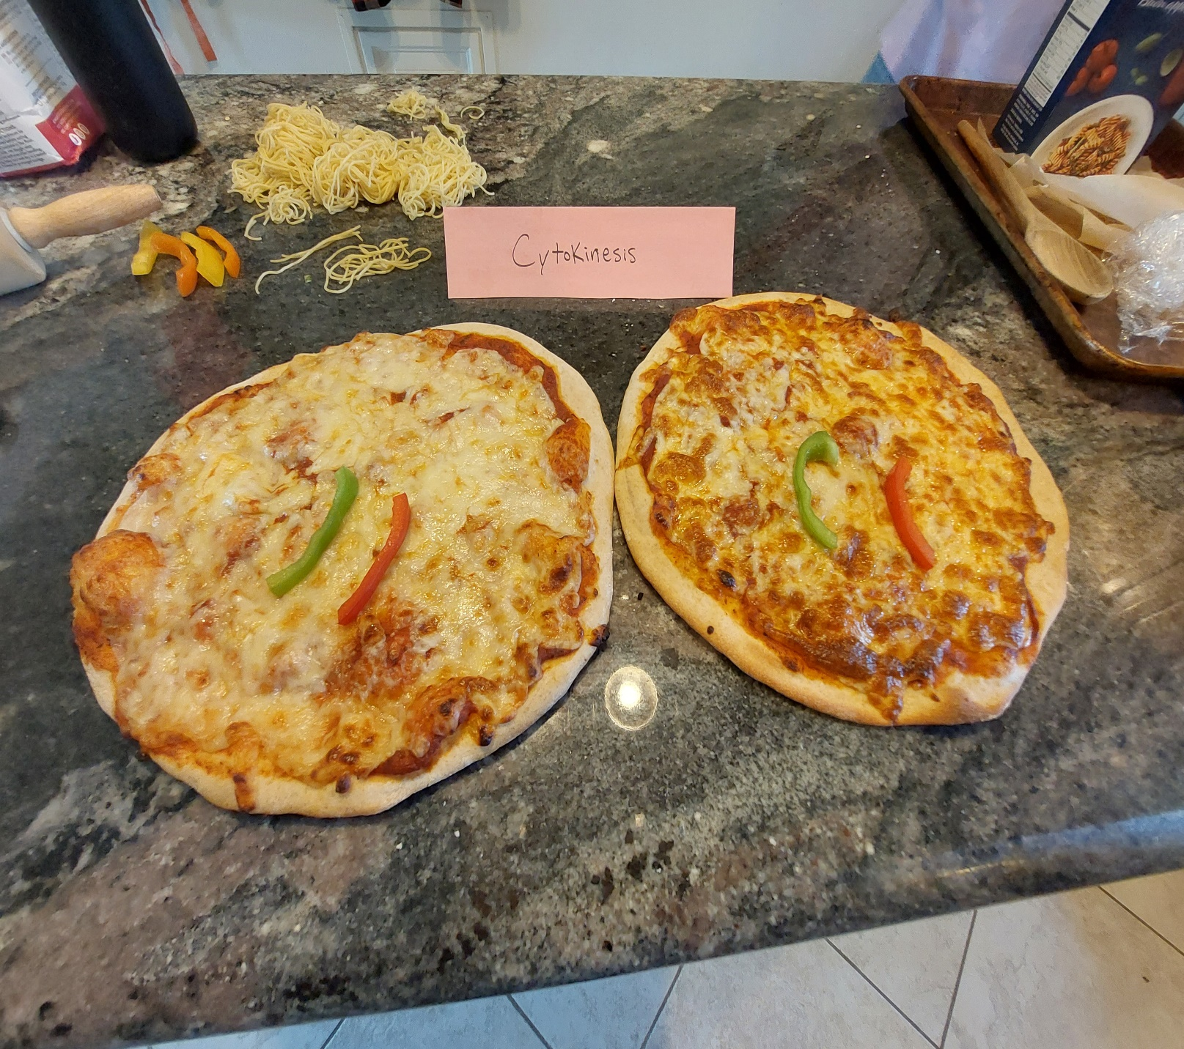

Figure 6 Cytokinesis

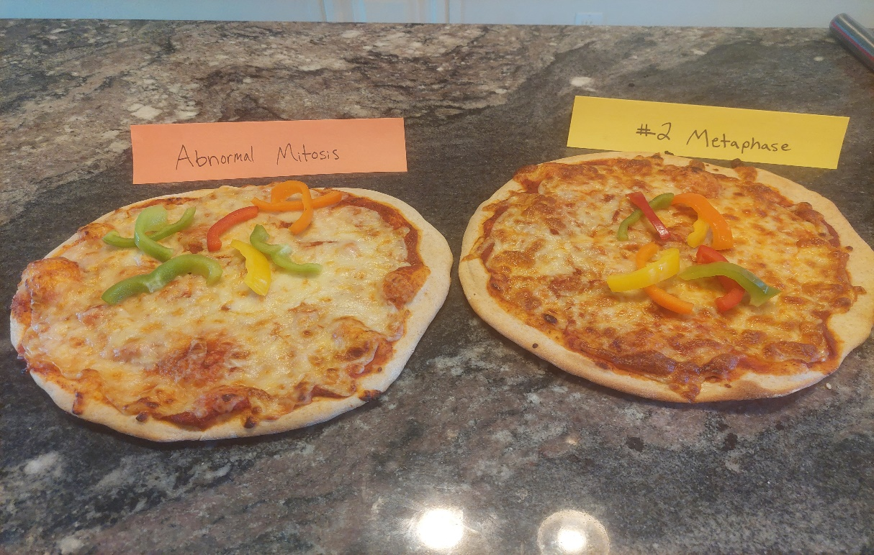

Figure 7 Abnormal Mitosis