what are the possible causes?  A majority of doctors aren’t aware of a specific cause. Therefore, there are many possible reasons that can allow a person to have this disorder.  Some of which is:  - Genetics factors  - Past down from family members that contained this disease  - Genetic mutations  - Viral infection that occurred within the bone’s cell  - Environmental factors  - Vitamin D and Calcium deficiencies  - Exposure to environmental toxins |  | Possible Symptoms of the disorder  - Majority of people who has this disease are asymptomatic  - Pain in the bones and joints  - Bone deformities  - Hearing loss  - Tingling or weakness  - Osteoarthritis  This disease commonly affects the skull, pelvis, head, legs, and the spine. |  | - an uncommon disorder that may occur  Paget’s disease of bone  A disease that interferes with the body’s bone tissue by constantly replaces old bone tissue. (Mayo Clinic)  Osteoclast (a cell in bones that absorbs bones) cells are interrupted, which causes the bones to break easily. Osteoblasts (cells in bones that repair and regrows bones) are activated and tries to repair the bones fast but are weaker and potentially larger. (National Health Service)

Diagnosis  During a doctor’s visit, they will run the following tests if they suspect that you may have this disease. (Mayo Clinic)  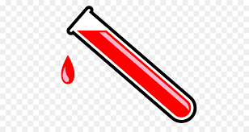  Blood tests  They would test the blood to see if there are any high levels of alkaline phosphate.  X-Rays and bone scans  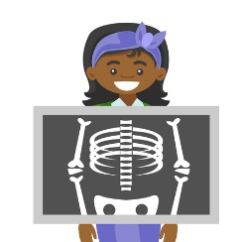  They would check for any abnormalities in the bones. An indicator may be broken down bones, or overgrowth of bones in certain areas.  With a bone scan, they would add radioactive material to find which area of the body is most affected. |  | Treatments for paget’s disease of bone  Unfortunately, there are no cures for this disease, but there are treatments that can help ease the symptoms.  Treatments includes:  - Oral or injectable medication prescribed by a doctor  - Anti-inflammatory medications  - Pain reliever medications  - In rare cases, surgery is needed.  - Realign broken bones to heal correctly  - Replace joint damages due to arthritis |  | Tips for people who may have this condition  - Eat well: eat foods that contains high levels of calcium and vitamin D  - Take calcium and vitamin D supplements  - Prevents falls that can potentially damage the bones  - Take precautions into your home to help decrease the chance of falling  - Exercise regularly.  - Consult with your doctor on exercises on the right intensity and won’t put further stress on your bones

