STEAM project, BIOL 112
Professor Don Larson
Faith Dalton
The Hormonal Changes Involved in Pregnancy and Parturition
Throughout pregnancy, there is an overall increase in endocrine gland function, which results in not only the increase in production of pregnancy-related hormones, but also an increase in the generally function and release of hormones the anterior pituitary gland. The hormone human chorionic gonadotropin, or hCG, is also referred to a as the “hormone of pregnancy”. hCG is detected in urine as soon as 8 days after conception. Home pregnancy tests typically test for hCG and have improved on accuracy since they were introduced in 1976. (C. Gnoth and S. Johnson, 2014). hCG is produced by trophoblast cells, and after implantation, the placenta produces increasing amounts of hCG. Human chorionic gonadotropin is made of two, non-covalently linked dissimilar subunits. Early in the first trimester, the rate of hCG increases at a rate of 50% per day, and peaks around the 10th gestational week, after which levels decrease slightly and remain stable for the remainder of the pregnancy.
Progesterone, initially produced by the corpus luteum, inhibits uterine contraction throughout the early stages of pregnancy. Progesterone levels rise steadily after about week 17 and peak throughout the 7th month, then drop. This hormone is crucial in maintaining pregnancy. (Chee Wai Ku, et all, 2018). Studies have shown that low levels of progesterone have a direct correlation with spontaneous abortion before week 16 of abortion, as compared with those showing normal levels. Progesterone acts as a smooth-muscle relaxant, as well as maintaining the uterine lining. In response to decreasing levels of progesterone late in the 3rd trimester, Braxton-Hicks contractions (false labor) may occur.
Estrogen and progesterone show a similar pattern of increase throughout pregnancy, but estrogens peak and level off around week 34, after which progesterone shows a gradual decline. Estrogen is a major hormone in maintaining pregnancy as well, and the affects thereof are very diverse. Estrogen contributes to lactic acid in the vagina during pregnancy by causing the proliferation of the lactobacilli (decreasing pH), and stimulates the production of cervical mucus, which makes the mucus plug. During pregnancy, the breasts are prepared for breastfeeding by estrogen, which triggers an increase in adipose tissue and prepares the ductiles, and progesterone, which enlarges the breast lobules that produce milk. Both estrogen and progesterone are produced by the ovaries until the placenta takes over, during the 2nd trimester, when the placenta takes over production of all the pregnancy-related hormones.
Before birth, usually around week 40, the levels of progesterone and estrogen drop, and parturition, or labor, begins, and the baby is born. At the onset of labor, when the baby is ready to leave the uterus, fetal stress stimulates the production of adrenocorticotropic hormone (ACTH). ACTH is released by the pituitary gland of the infant, which, in turn, stimulates the release of cortisol. Fetal cortisol effects the placenta by decreasing progesterone and estrogens levels but increasing prostaglandins. Prostaglandins cause the uterus to contract. Nerve fibers in the uterine region stimulate the hypothalamus to produce oxytocin. Also prior to labor, the myometrium’s sensitivity to oxytocin is increased by expressing more specific receptors.
Oxytocin is stored and released from the posterior pituitary gland is primarily responsible for uterine contractions and the production of more prostaglandins. (Kerstin Uvnas-Moberg, et all, 2019) Oxytocin is found to have many positive effects on a laboring mother, including psychological benefits, like stress management. Oxytocin is released in spurts to produce rhythmic contractions.
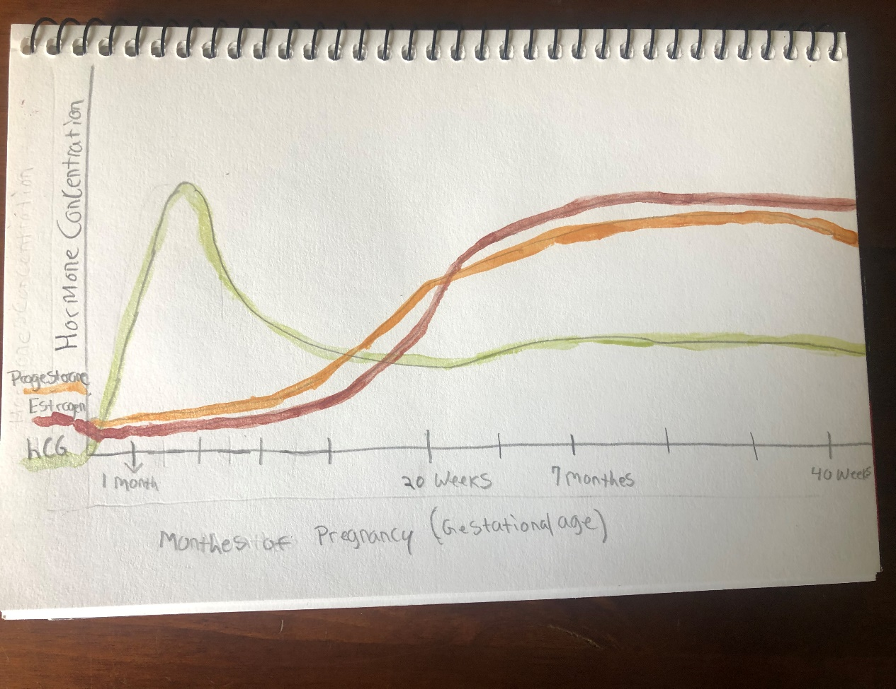
https://www.ncbi.nlm.nih.gov/pmc/articles/PMC4119102/
https://bmcpregnancychildbirth.biomedcentral.com/articles/10.1186/s12884-018-2002-z
https://bmcpregnancychildbirth.biomedcentral.com/articles/10.1186/s12884-019-2365-9

