STEAM project
BIO F111
Professor Don Larson
Faith Dalton

The Stages of Bone Development from Conception to Adolescence

In the first six weeks after conception, an embryo’s skeleton is made of fibrous membranes and hyaline cartilage, which will become the platform for bone. By seven weeks after conception, ossification begins. Ossification is the process of bone development and is done one of two ways, by intramembranous ossification or by endochondral ossification. (G. Breeland, M. Sinkler, R. Menezez, 2021)
Endochondral ossification is how most bones of an infant are developed before birth. (G.Galea, 2020). Bone is ossified by this process in the fetal skeleton to replace the hyaline cartilage of the skeletal template. On the first model, cartilage cells, called chondrocytes, can be seen as they differentiate from mesenchymal cells around seven weeks on a long bone. The example shown is a femur. A membrane, called the perichondrium, forms around the bone.
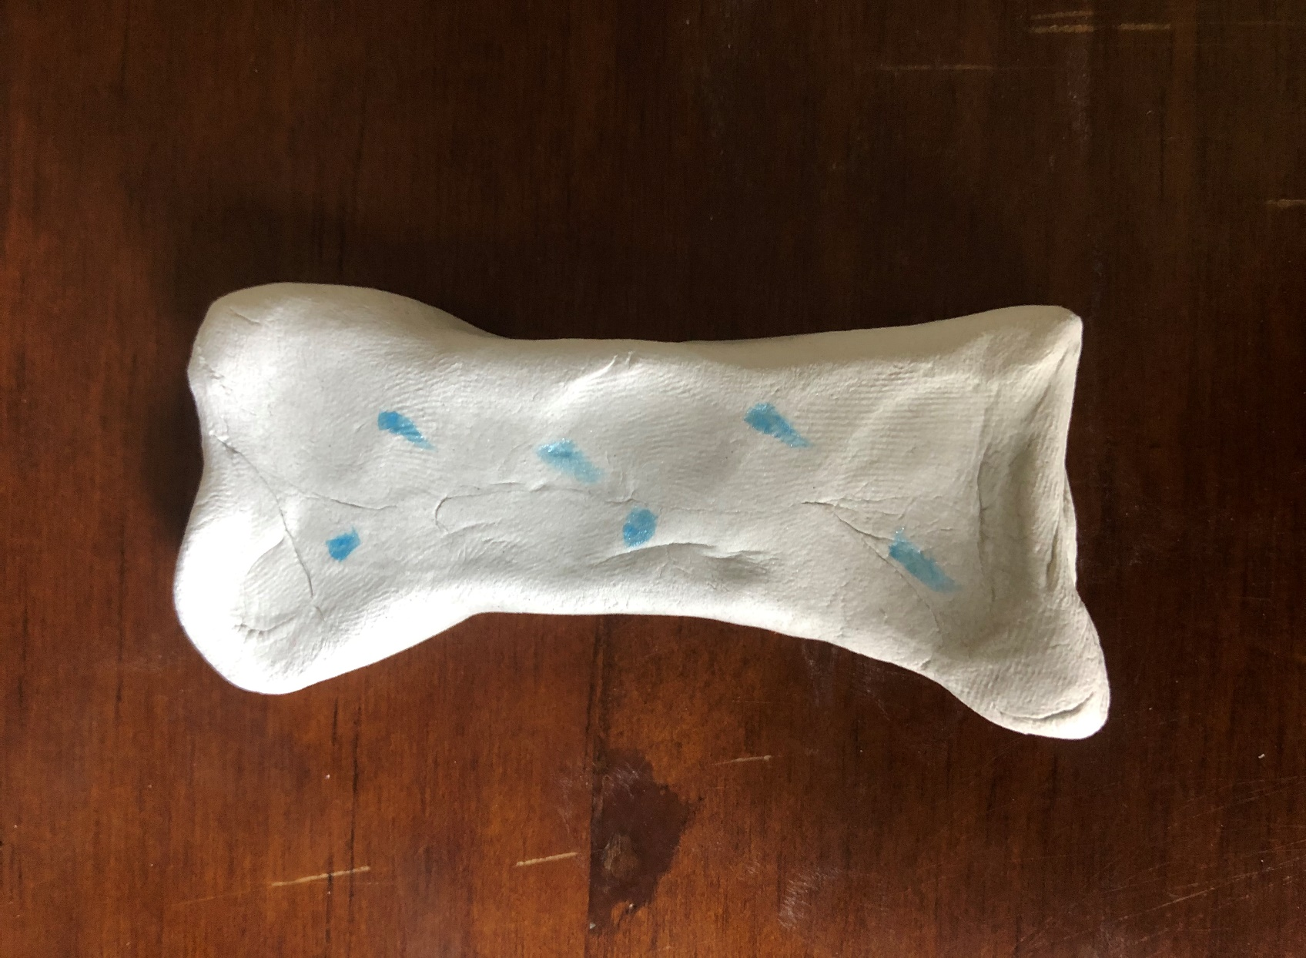
In the next image, more matrix can be seen, as the chondrocytes grow in size.
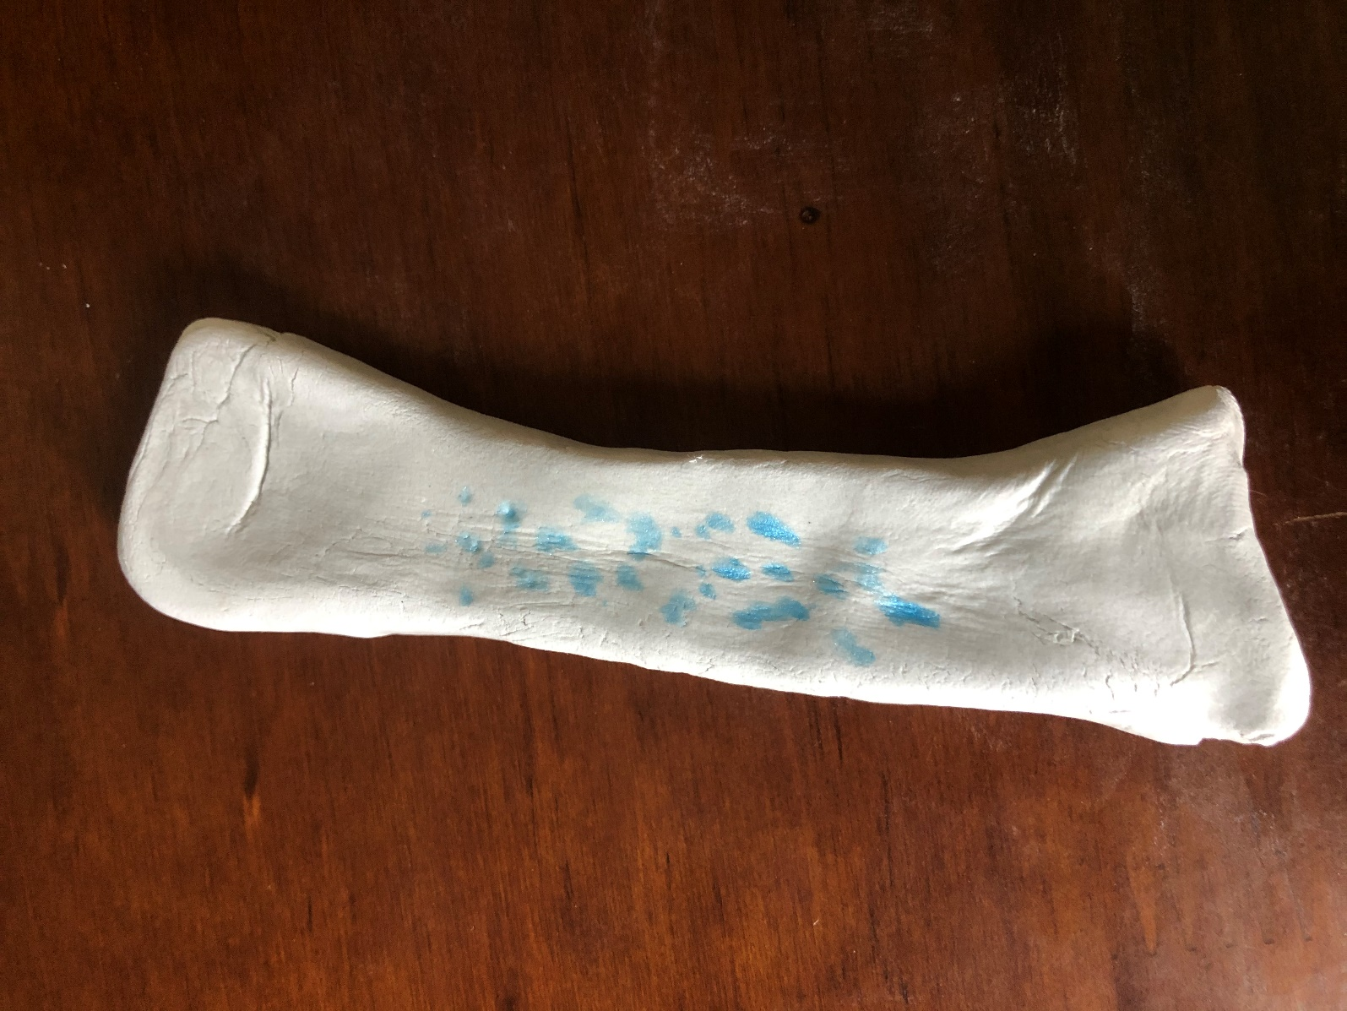
Then, the chondrocytes begin to die off and the cartilage begins to disintegrate. The bone matrix is now preventing the chondrocytes from getting nutrients, which causes their death. The space that is left by the cartilage fibers is filled with blood vessels (arteries shown in red).
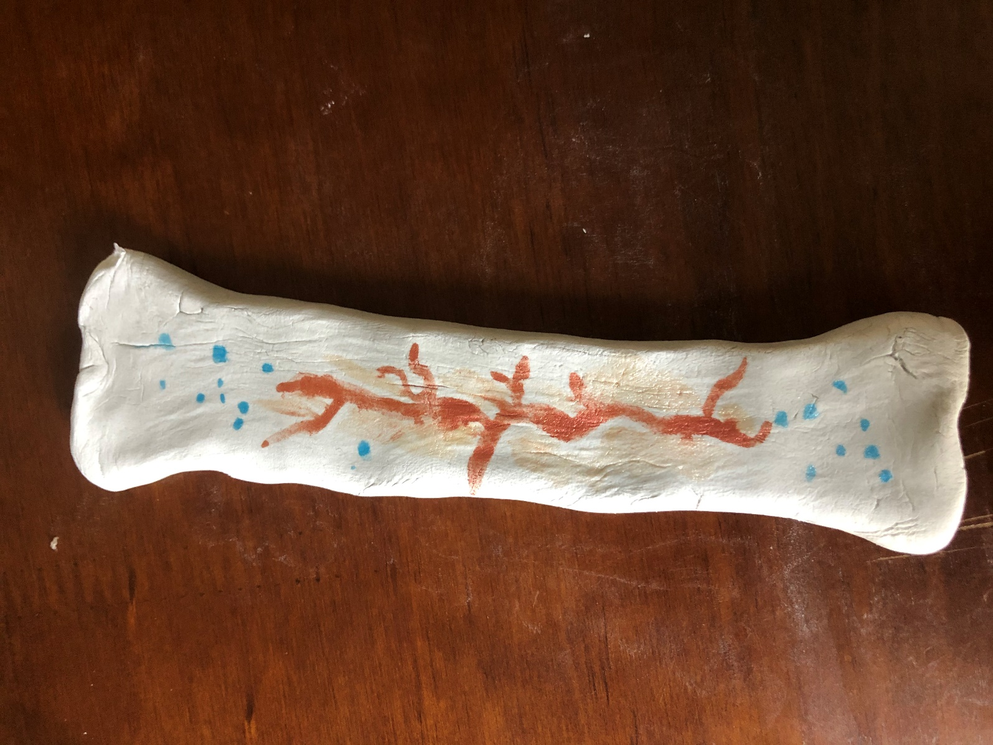
The blood vessels in what is now the medullary cavity bring in osteogenic cells, which develop into osteoblasts. Osteoblasts are what eventually turn to bone. In the next model, a vein can now be seen, represented by blue.
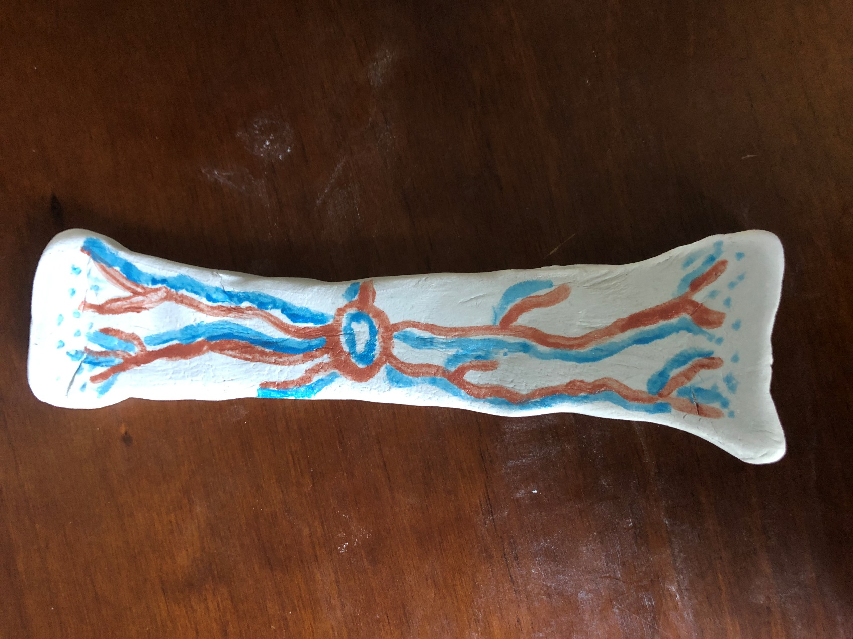
The cartilage grows, and the capillaries penetrating it triggers the perichondrium to transform into the periosteum, which produces bone.
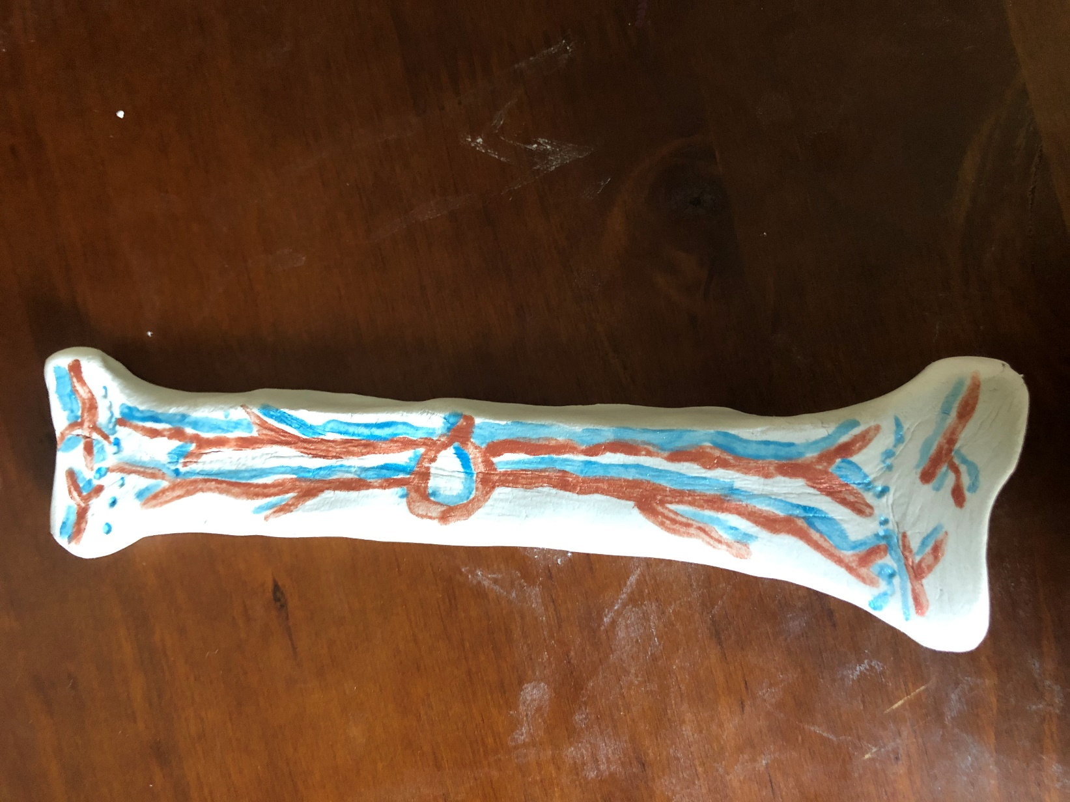
The osteoblasts form a collar of compact bone around the cartilage of the diaphysis. By three months after conception, ossification is priority in the fetal skeleton. The long bones now have a primary ossification center deep in the periosteal collar and a secondary ossification center. At birth, most of the cartilage of the skeleton has been replaced with fully formed endochondral bone matrix, except at joints and between the diaphysis and epiphysis.
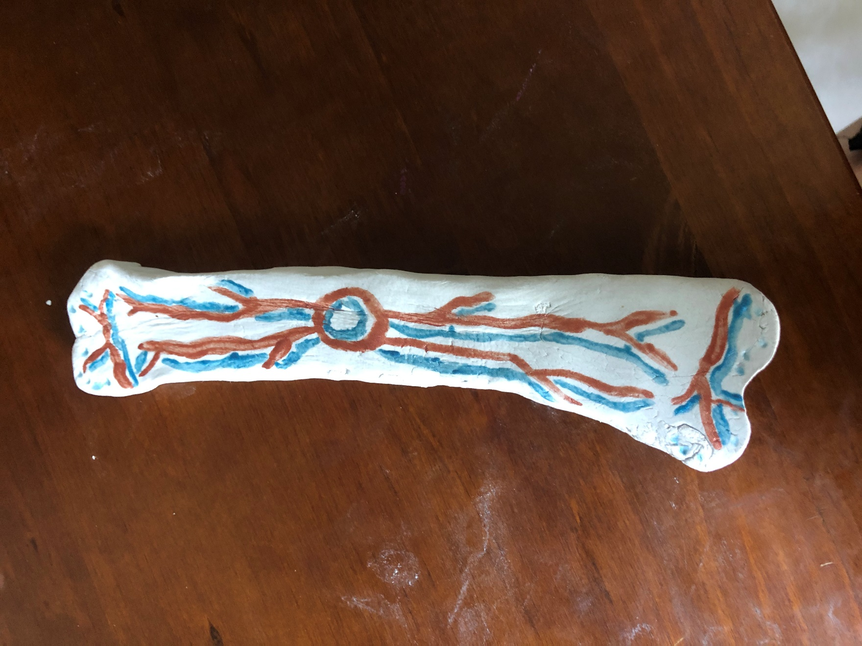
As shown in the last model, the ends of the long bone have capillaries at the epiphyseal plate, which continue the process of bone lengthening until adolescence.
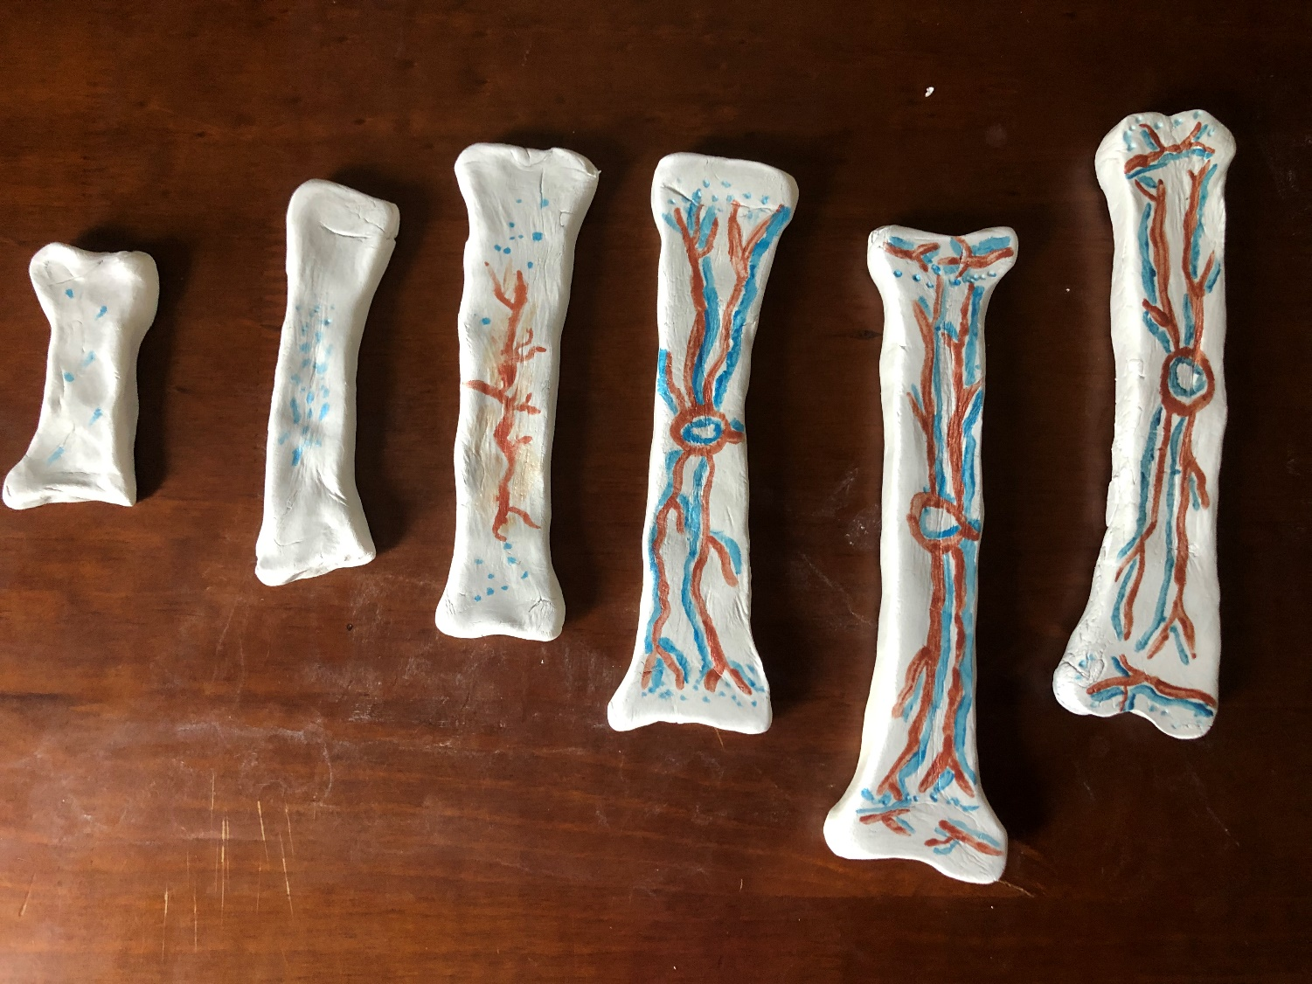
The process of intramembranous ossification is how the flat bones of the skull, mandible, maxilla, and clavicle are formed. (A. Salhotra, et al, 2020) During this pathway for osteogenesis, the mesenchymal cells of the embryonic skeleton are concentrated into specialized cells, including capillaries and osteoblasts. This cluster of osteoblasts is referred to as an ossification center. Osteoid, an uncalcified matrix is released from these osteoblasts. The osteoid hardens within a few days and traps the osteoblasts within, where they become osteocytes (bone cells). Osteogenic cells in the surrounding tissue continue to transform into osteoblasts in the same manner and the osteoid is secreted around nearby capillaries. The osteoblasts on the surface eventually become spongy bone, which is then converted to the periosteum. The periosteum serves as the protective layer around the trabecular bone. The blood vessels that are soon crowded out morph into red bone marrow. The skull and clavicle are not fully ossified at birth but continue to ossify until adulthood, and the flat bones of the face are the last to complete intramembranous ossification.
Works cited:
NCBI, April 2021 Embryology, Bone Ossification by G. Breeland et. All
https://www.ncbi.nlm.nih.gov/books/NBK539718/
NCBI, December 2020 Making and Shaping Endochondral and Intramembranous Bones by G. Galea et al
https://www.ncbi.nlm.nih.gov/pmc/articles/PMC7986209/?report=classic
NBCI, September 2020 Mechanisms of Bone Development and Repair A. Salhotra et al.
https://www.ncbi.nlm.nih.gov/pmc/articles/PMC7699981/

