Bone fractures are the most common large organ injuries in humans and in the course of a lifetime people will be likely to experience two bone fractures. Bone fractures can be caused from minor accidents such as falls or they can result from major traumatic experiences like car accidents. There are three “either/or” fracture classifications. The positions of the bone in relation to the skin after a fracture occur determine whether it’s labeled as a closed or open fracture. An open fracture requires that at least one end of the broken bone protrudes from the skin. The healing process in an open fracture is similar to a closed fracture but the typical open fracture takes considerably longer to heal because the bone is exposed to the elements and susceptible to infection. A closed fracture is still a broken bone but the bone fragments are contained within the skin. The image labeled as #1 is a representation of an open fracture and the picture labeled #2 is an example of a closed fracture. The typical procedure to heal an open fracture requires the use an implanted material to hold the bones in alignment to help the recovery process. Bone fractures can be further classified into being completely fractured or incomplete fractured. An incomplete fracture refers to a bone that has endured partial damage yet retains continuity along its structure in some form (image 3). A complete fracture is when the bone damage has gone through the entire structure of the bones and severed any continuity (image 4). Both complete and incomplete fractures can fall under the classification of closed or open fracture. Image 5 represents an open/complete fracture, image 6 represents a closed/incomplete fracture, image #7 represents a open/incomplete fracture, and image 8 represents a closed complete fracture. The last two types of classifications are called displaced and nondisplaced. In a displaced fracture the ends are out of normal alignment while in nondisplaced fractures the ends retain their normal positions. Image #9 is of a nondisplaced fracture and image #10 is of a displaced fracture.
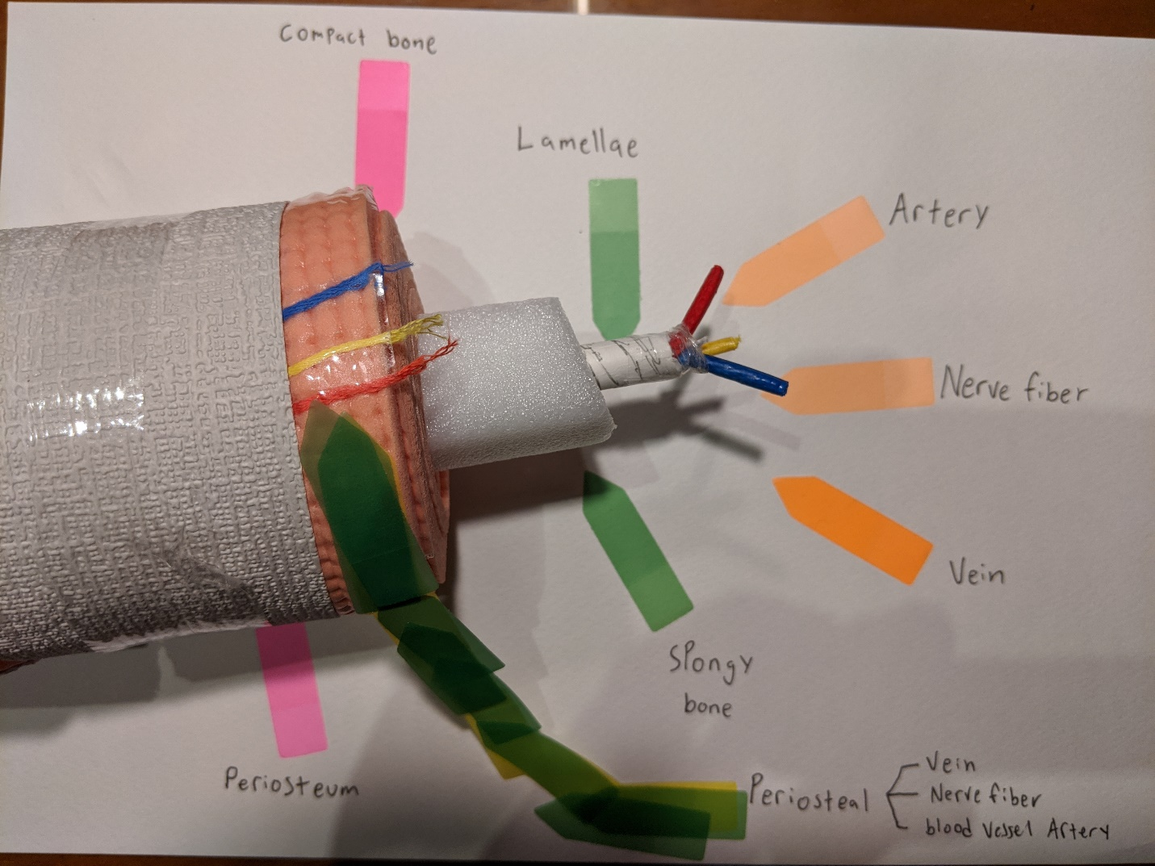
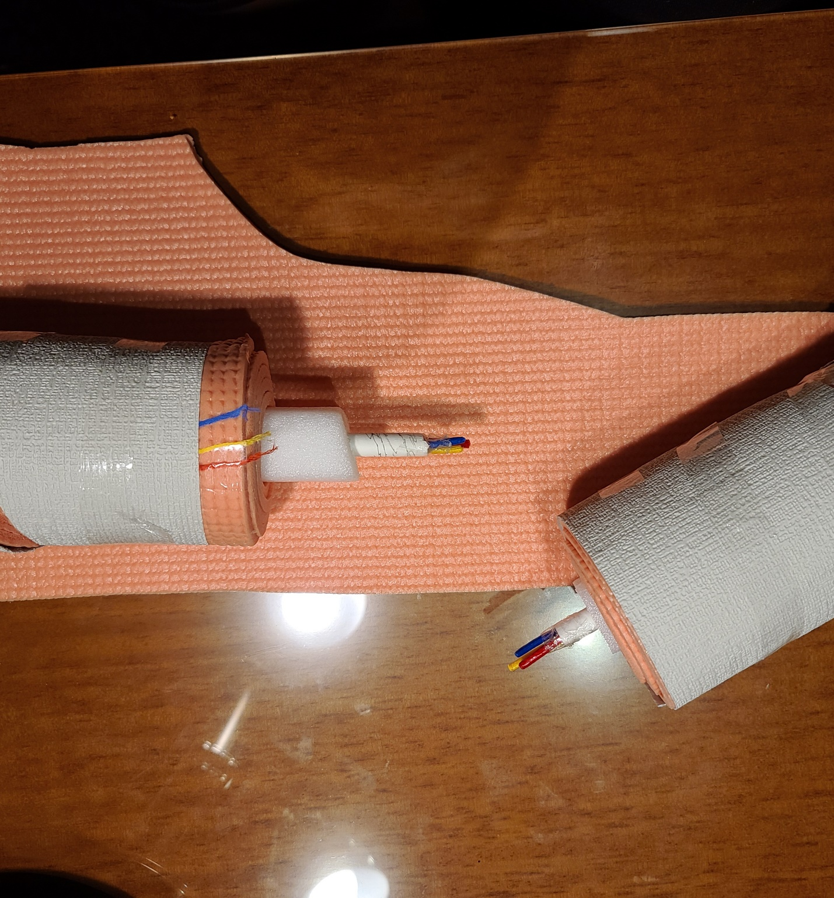
Image #1,5, 10

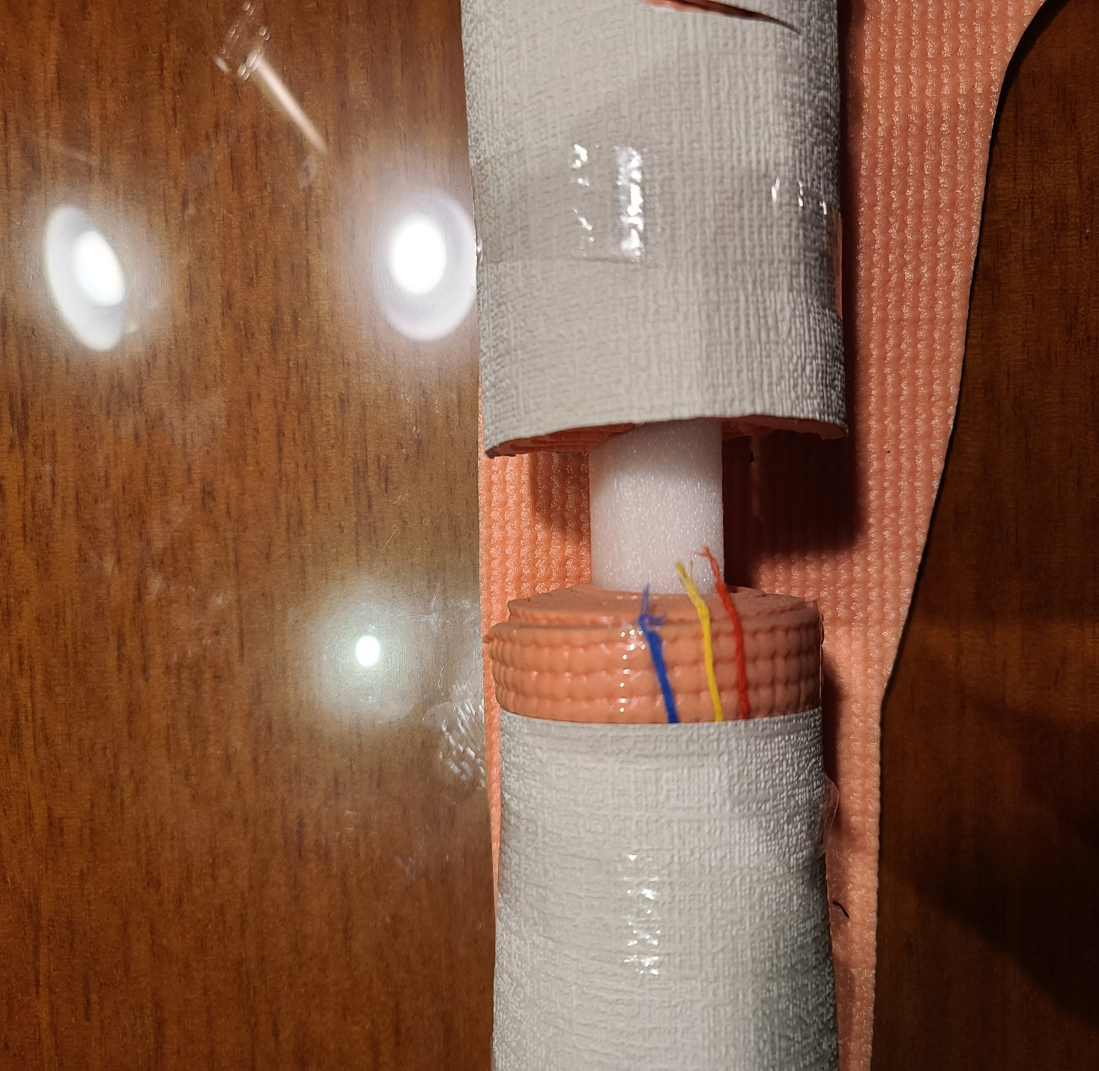
Image #2,
Image #3, 6
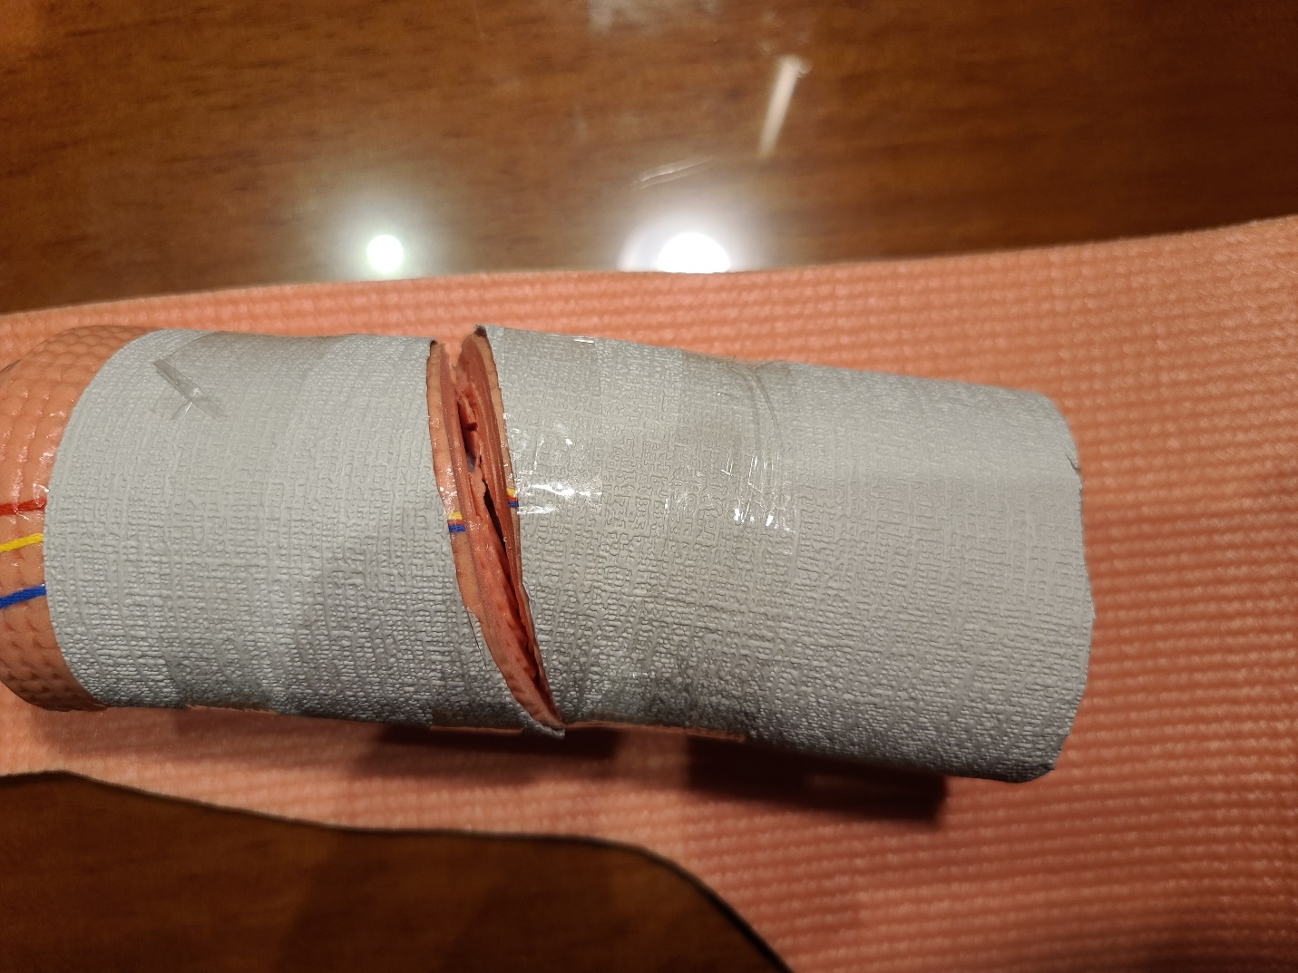
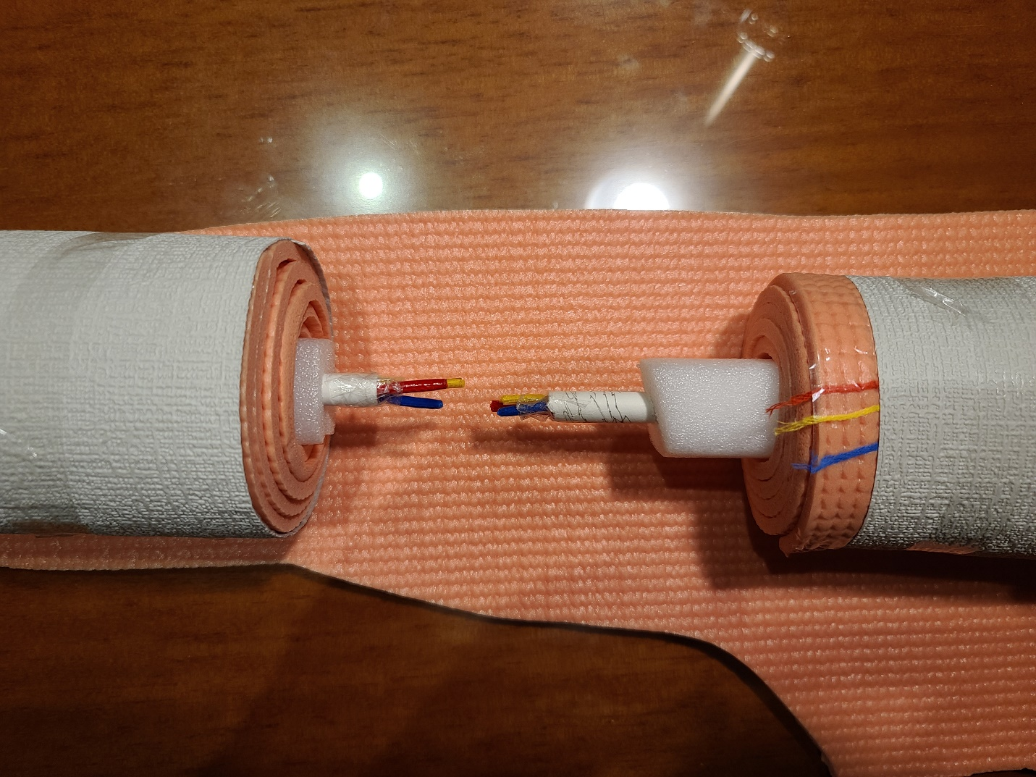
Image #4, 8
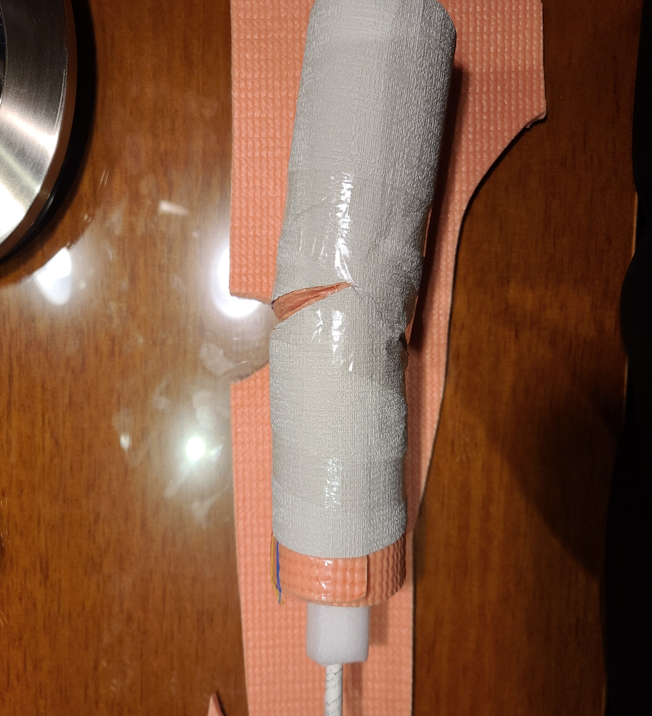
Image #7
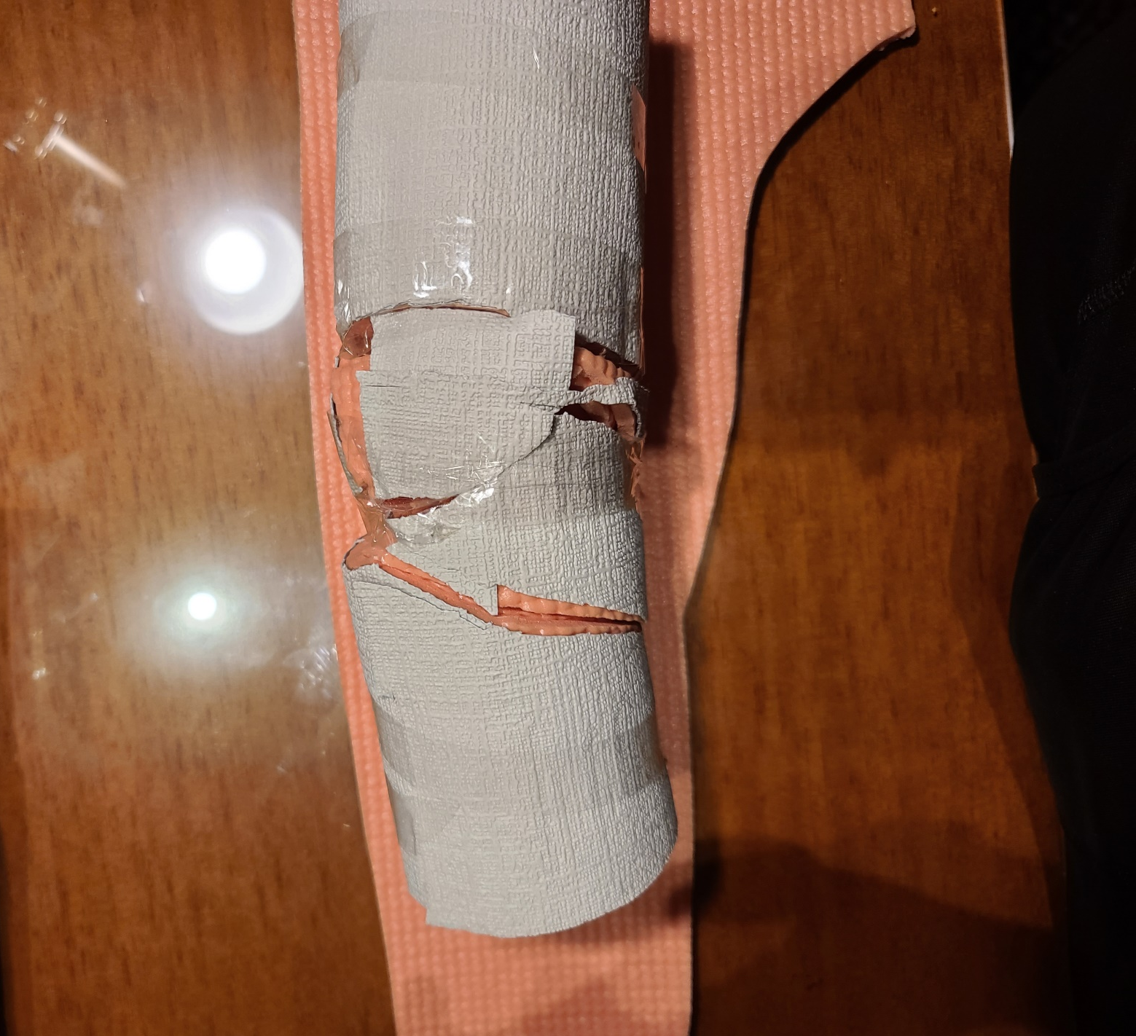
Image #9

