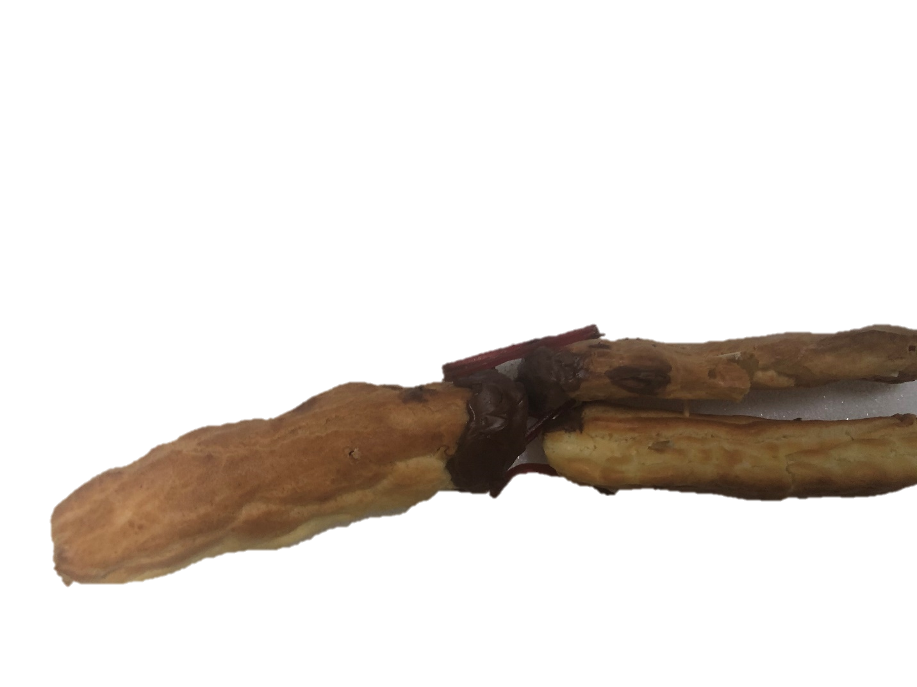v

Worn down articular cartilage

Lateral collateral ligament

Fibular Collateral ligament

Fibula

Tibia

Femur 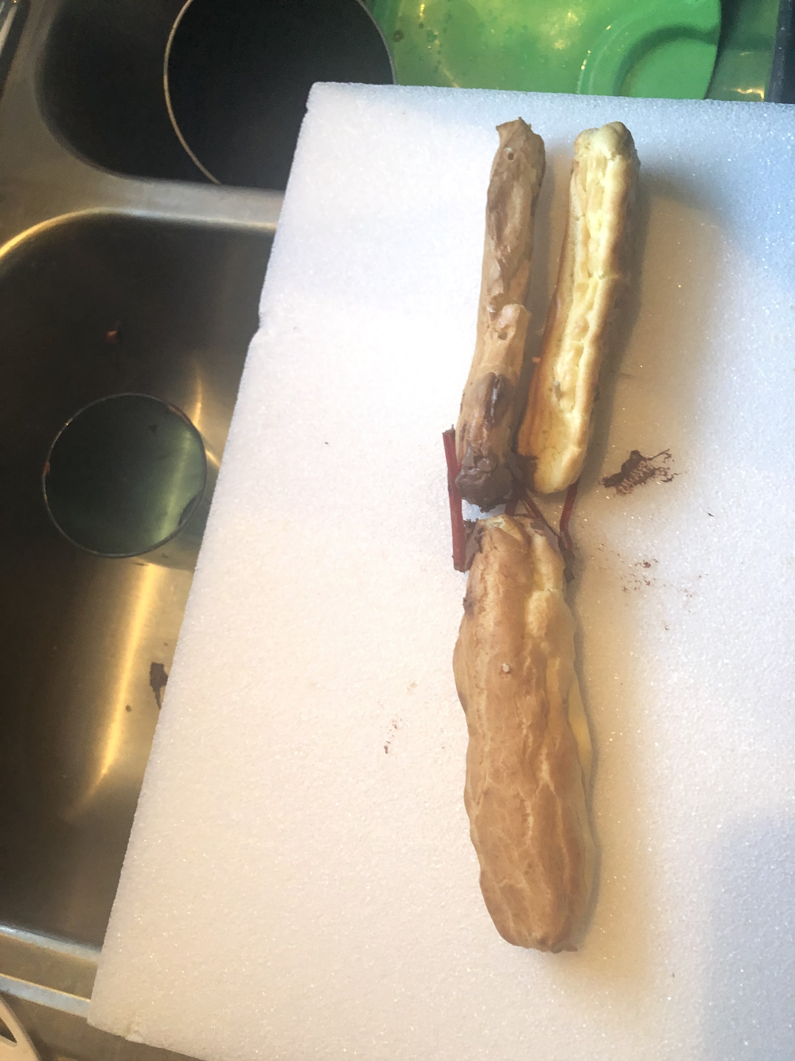ur

Articular cartilage

Fibular collateral ligament

Tibia

Fibula

Femur ur

Lateral collateral ligament