DR. BIO’S BOOK ON MITOSIS!

HELLO! MY NAME IS DR. BIO! TODAY WE’RE GOING TO GO OVER A COOL PROCESS I’D LIKE TO CALL, “MITOSIS!”

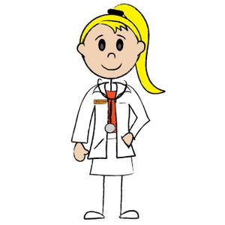

MITOSIS IS WHERE TWO SMALL PARTICLES CALLED CELLS DIVIDE IN A WAY THA GIVES THEM TWO DAUGHTER CELLS! (LIKE A MOMMY AND DADDY) THESE DAUGHTER CELLS HAVE THE SAME NUMBER OF CHROMOSONES AS THEIR PARENT CELLS!

THE FIRST PART OF MITOSIS IS CALLED INTERPHASE! (IN-TER-PHASE)

THE FIRST FAZE IS CALLED INTERPHASE! (IN-TER-PHASE)!

INTERPHASE IS THE RESTING PERIOD BETWEEN THE SPLITTING OF THE CELLS!

INTERPHASE IS MEANT TO COPY AND REMAKE DNA FOR CELL DIVISION!

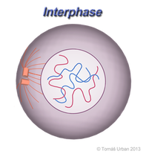

THE SECOND PHASE IS CALLED PROPHASE (PRO-PHASE)!

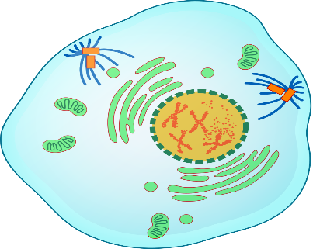
PROPHASE IS THE FIRST THING THAT HAPPENS AFTER DNA IS COPIED! YOU CAN NOW SEE THE CHROMOSNES (THE THINGS THAT MAKE YOU, YOU!) BUT NOW THEY ARE PAIRED AS THINGS CALLED CHROMOTIDES! (CHRO-MO-TIDE)

THE PURPOSE OF PROPHASE AND IT’S PAIRS IS TO CONDENSE DNA!

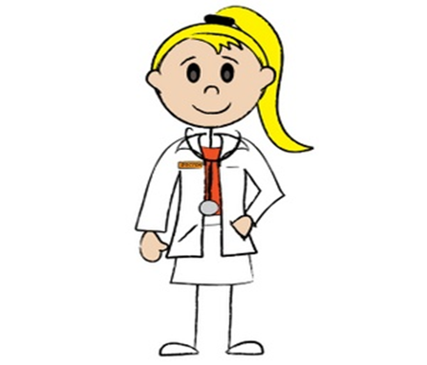
NOW WE HAVE WHAT WE CALL…METAPHASE!!
THIS MEANS WE ARE ALMOST DONE WITH OUR MITOSIS PROCESS!
METAPHASE(MET-A-PHASE) IS THE STEP WHERE CHROMOSONES (CHRO-MO-SONES) BECOE ATTACHED TO THESE LITTLE FIBERS, CALLED “SPINDLED FIBERS”. IN METAPHASE, YOUR CHROMOSONES COME TOGETHER IN THE MIDDLE OF THE CELL! THEN SEPERATESEPERATE THE CHROMOTIDES YOU LEARNED ABOUT EARLIER! SPINDLE FIBERS HELP DIVIDE DNA IN CELLS!

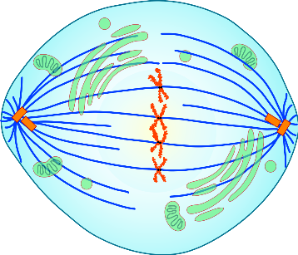

THIS BRINGS US TO ANAPHASE! (AN-NA-PHASE) WHICH HAS A LOT OF SIMILARITIES LIKE THE PREVIOUS STEP, METAPHASE!
LIKE METAPHASE(MET-TA-PHASE), ANAPHASE(AN-NA-PHASE) THE CHROMOSONES MOVE AWAY FROM EACHOTHER TO DIFFERENT ENDS OF TH SPINDLE FIBERS! REMEMBER, THESE HELP IN DIVIDNG FOR THE CELL!

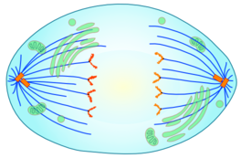
WOW! WE HAVE LEARNED SO MUCH TOGETHER AND I CANNOT BELIEVE WE ARE ALMOST DONE! ISN’T THIS EXCITING!?

LET’S TALK ABOUT OUR NEXT TO LAST STEP…TELOPHASE! THIS IS ONE OF THE LAST STEPS TO FINSH MAKING ONE CELL INTO TWO!!
TELOPHASE (TELL-OH-PHASE) IS THE LAST STEP IN CELLULAR DIVISION! THIS IS WHERE THE TWO CHROMATIDE THAT WE LEARNED ABOUT EARLIER, WHICH ARE NOW ON OPPOSITE ENDS, ARE NOW FORMING NUCLEI!! ISN’T THIS EXCITING!? THEY ARE ALMOST TWO COMPLETE CELLS FROM ONE!
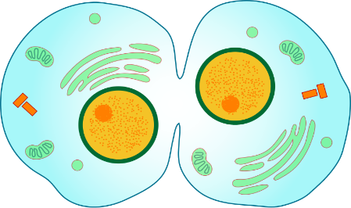

AND NOW WE CAN ADMIRE ALL OF THE HARDWORK MITOSIS DID TO GIVE US THESE TWO BEAUITIFUL SISTER CELLS!?

THIS IS ALSO CALLED CYTOKENSIS! (SIGH-TOE-KEN-SIS) WHICH MEANS WE ARE LOOKING AT TWO DAUGHTER CELLS (SISTER CELLS) WHICH IS ONE CELL DIVING IN TO TWO!

WASN’T THIS EXCITING? I REALLY ENJOYED GOING OVER THIS WITH YOU AND NOW YOU CN TEACH YOUR FRIENDS AND FAMILY ALL ABOUT MITOSIS AND THE IMPORTACE OF IT WHEN IT COMES CELL DIVISION AND MAKING PEOPLE UNIQUE WITH THER D-N-A!

I’LL SEE YOU LATER, ALL YOU FUTURE SCIENTISTS! BYE!

ONE LAST THING! WHEN YOU LOOK ON THE INTERNET TO HELP YOU WITH YOUR HOMEWORK IT IS A REALLY GOOD IDEA TO GIVE CREDIT TO THE PEOPLE OR WEBSITES THAT HELPED YOU!

WE CALL THESE WORKS CITED! I HAVE INCLUDED MINE BELOW AND EXTEND MY THANKS TO ALL THESE WONDERFUL PEOPLE WHO HELPED US LEARN ABOUT IITOSIS TOGETHER!
WORKS CITED:
Bailey, R. (n.d.). The Stages of Mitosis and Cell Division. Retrieved November 25, 2020, from https://www.thoughtco.com/stages-of-mitosis-373534
The cell cycle and mitosis review (article). (n.d.). Retrieved November 25, 2020, from https://www.khanacademy.org/science/high-school-biology/hs-reproduction-and-cell-division/hs-the-cell-cycle-and-mitosis/a/hs-the-cell-cycle-and-mitosis-review
D'Erfurth, I., Jolivet, S., Froger, N., Catrice, O., Novatchkova, M., & Mercier, R. (n.d.). Turning Meiosis into Mitosis. Retrieved November 25, 2020, from https://journals.plos.org/plosbiology/article?id=10.1371%2Fjournal.pbio.1000124

