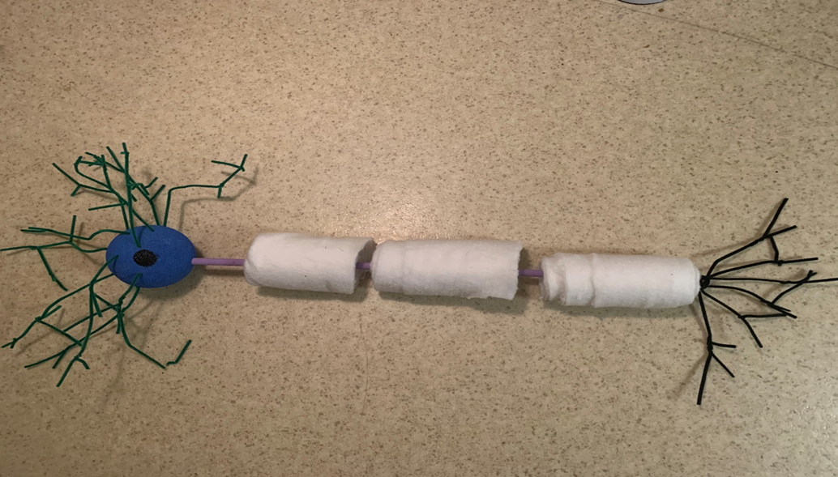

Axon terminal branch

Axon

Myelin

Dendrites

Nucleus

Soma/Cell Body

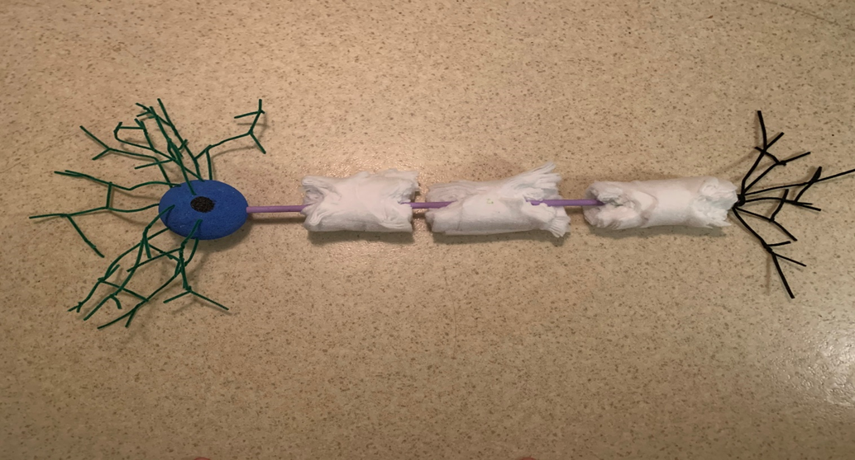

Damaged myelin sheath

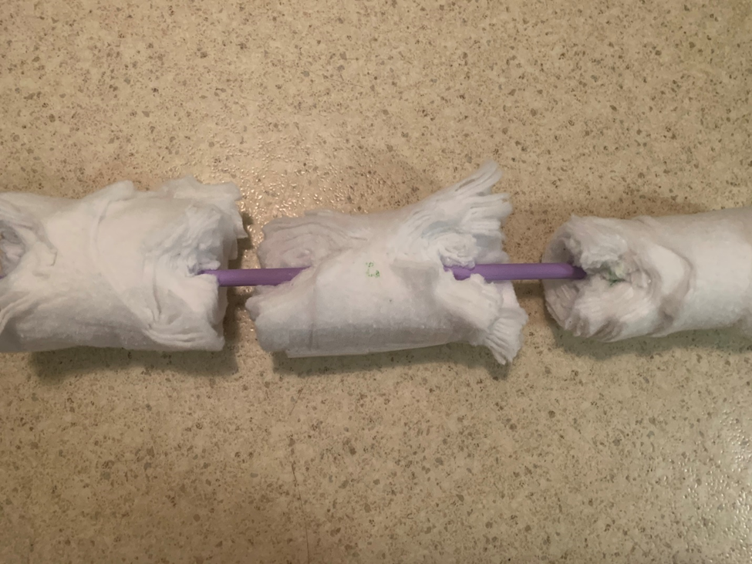

Layers of myelin

Damaged myelin sheath

Exposed axon