Depressed Brain vs. Normal Brain

Charlie and Bob

This is Bob in the red hat and Charlie (green hat). Bob and Charlie are twins. They did everything together and were always very happy.

Bob and Charlie were two peas in a pod. They loved doing things together.

They even dressed the same.

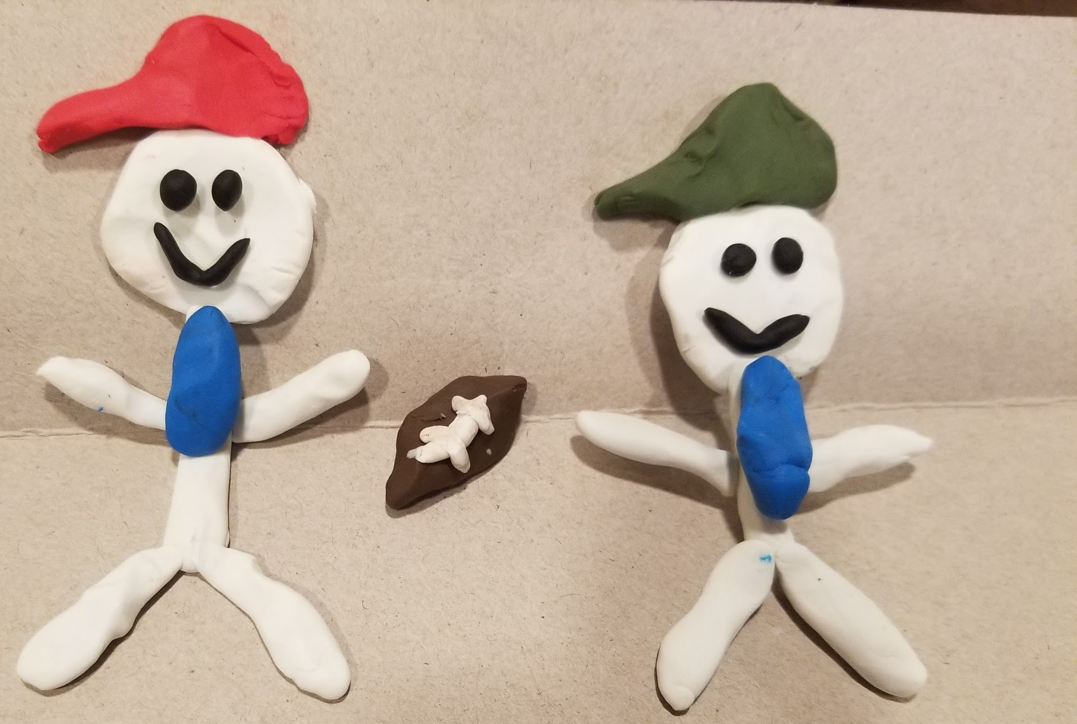 They joined their football team and loved sports.

One day in a tragic accident Charlie and Bob’s mom passed away. Their mom was their rock and she was gone in an instant.

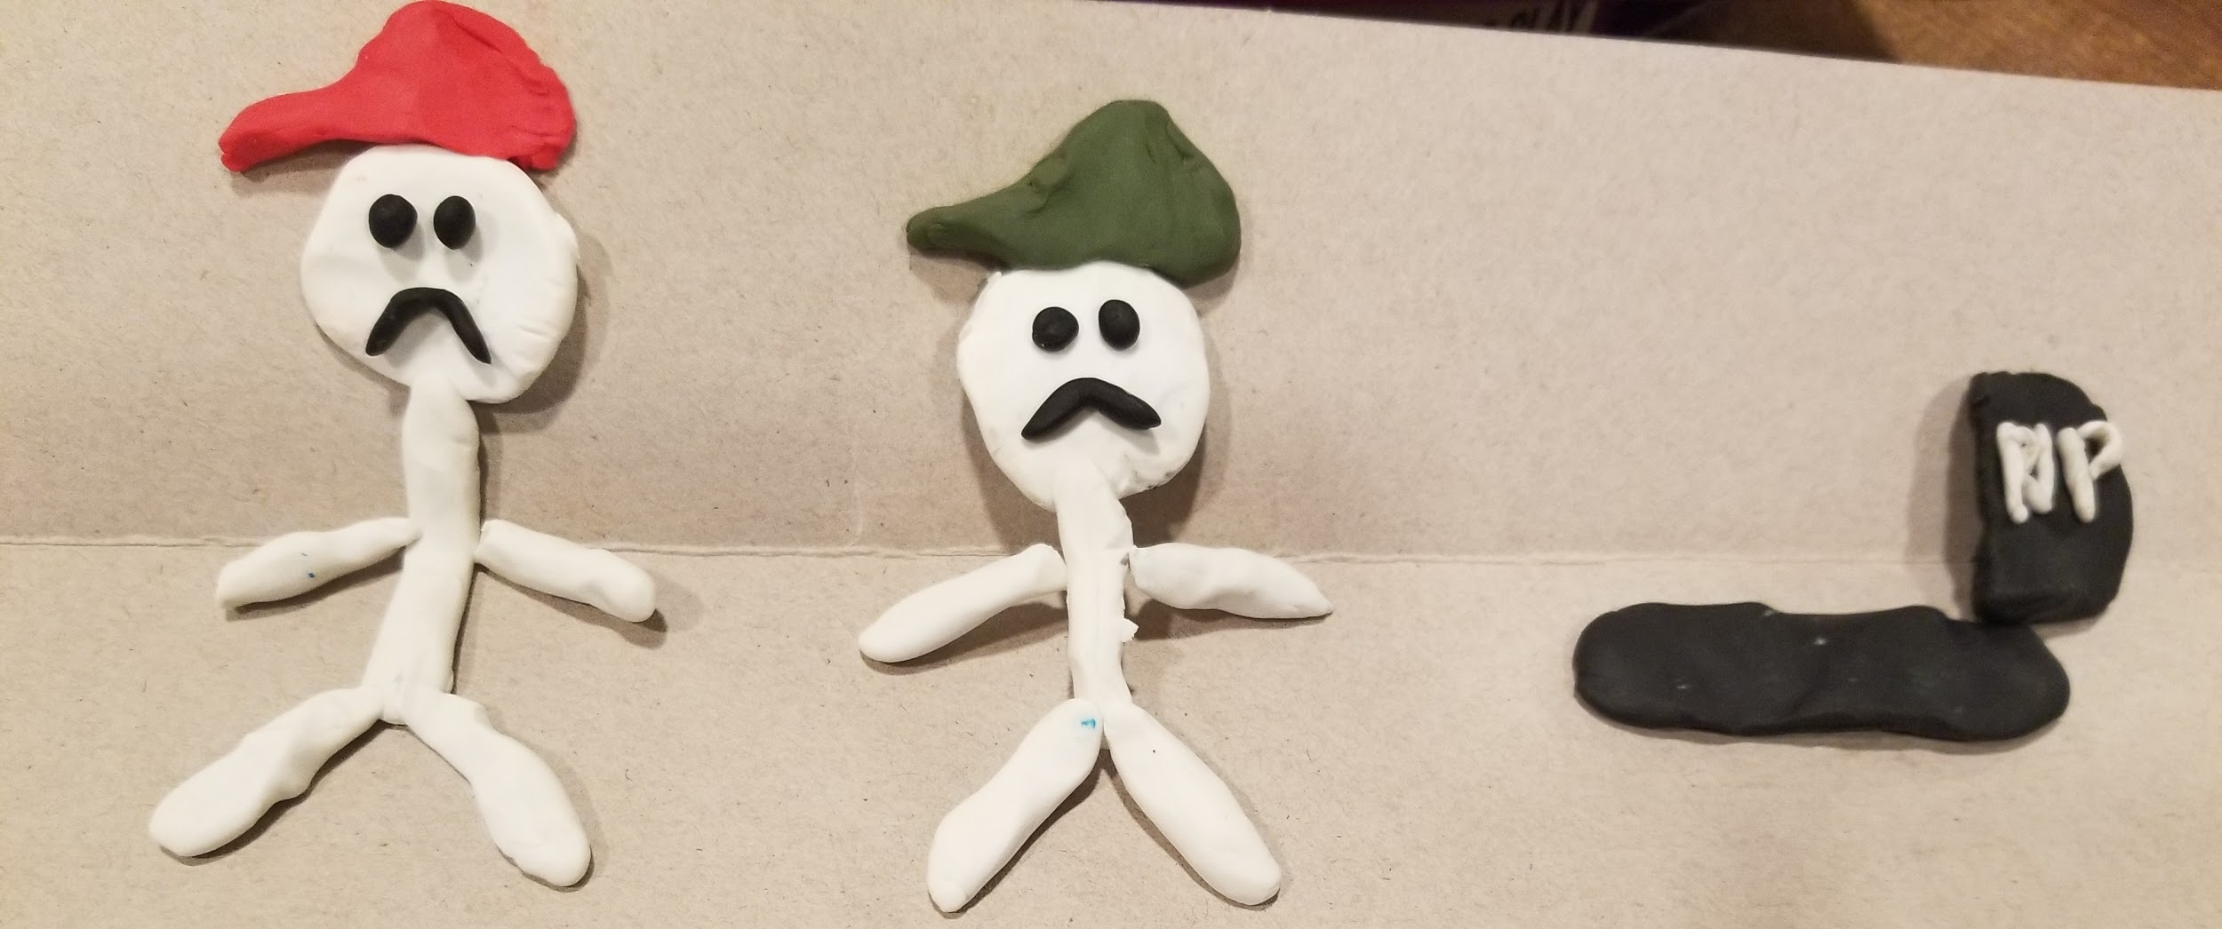

Bob was sad that his mom passed away, but he kept busy and eventually was his happy self again.
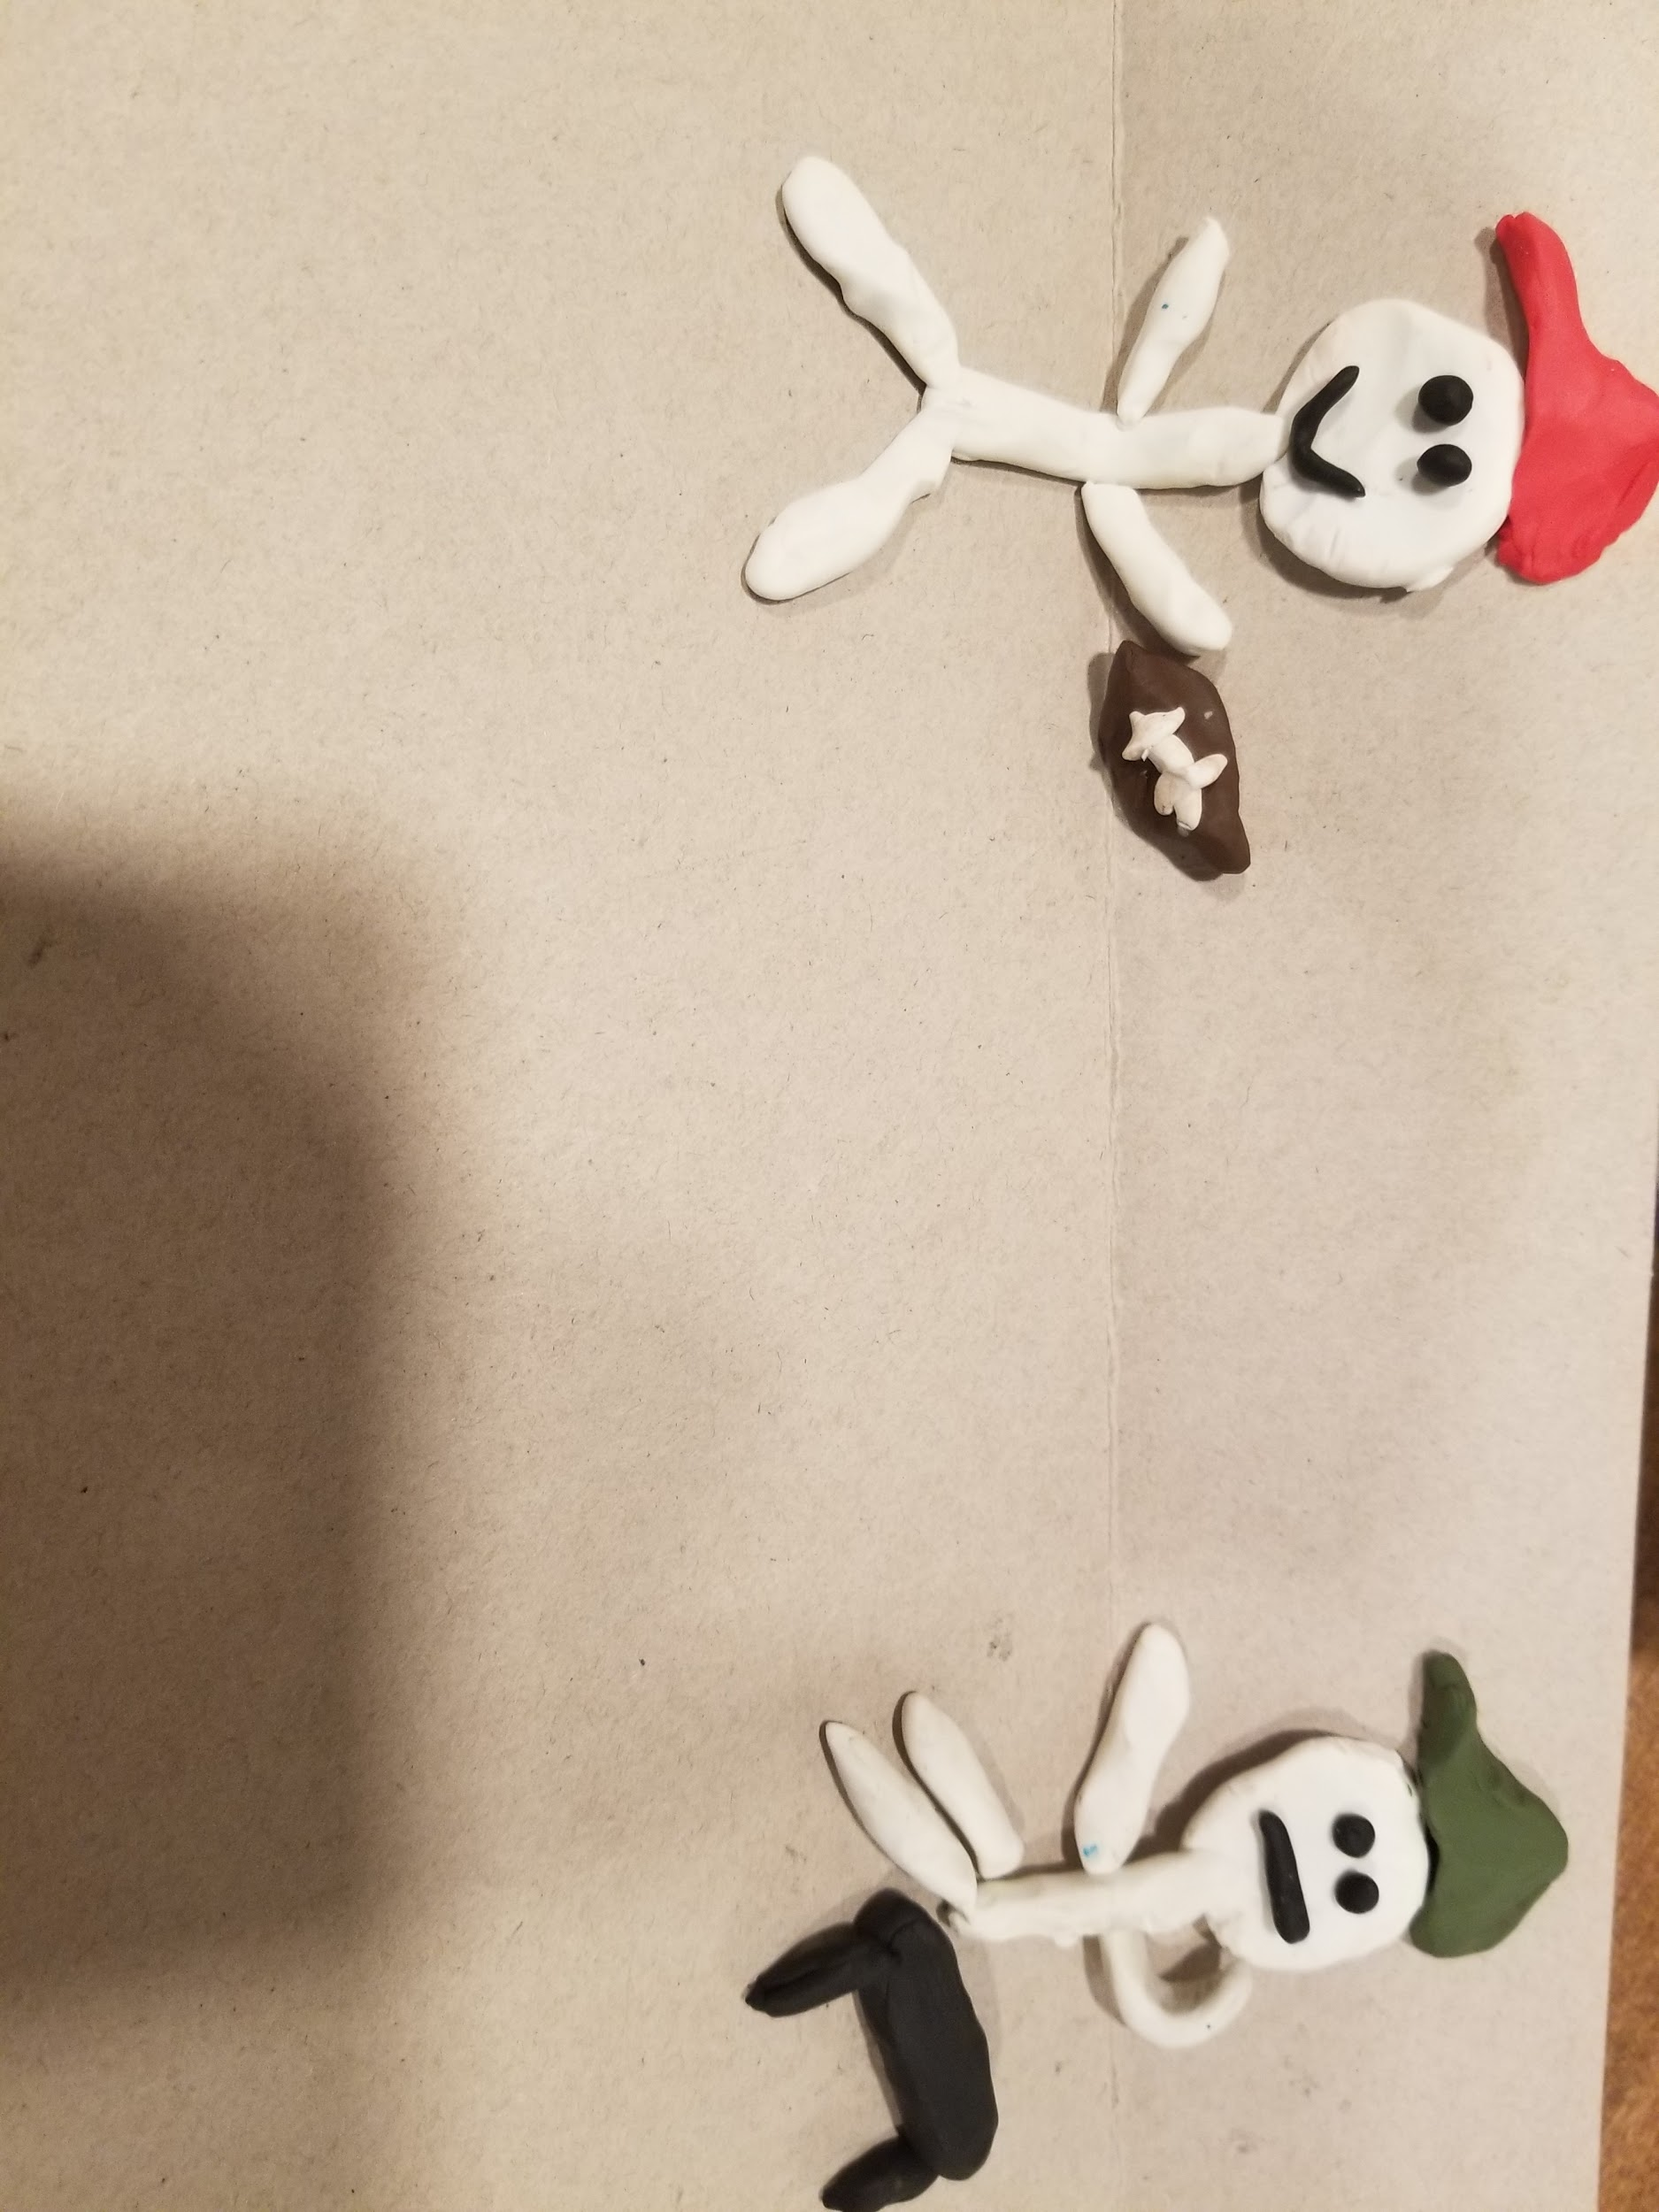

Bob tried to encourage Charlie by playing football, but Charlie was just upset. He didn’t want to play football anymore.
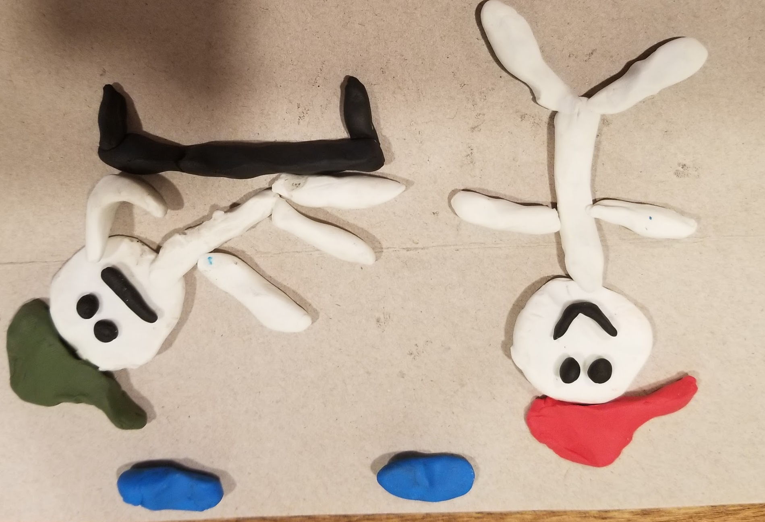 Eventually, Charlie started losing interests in hobbies and was always down.
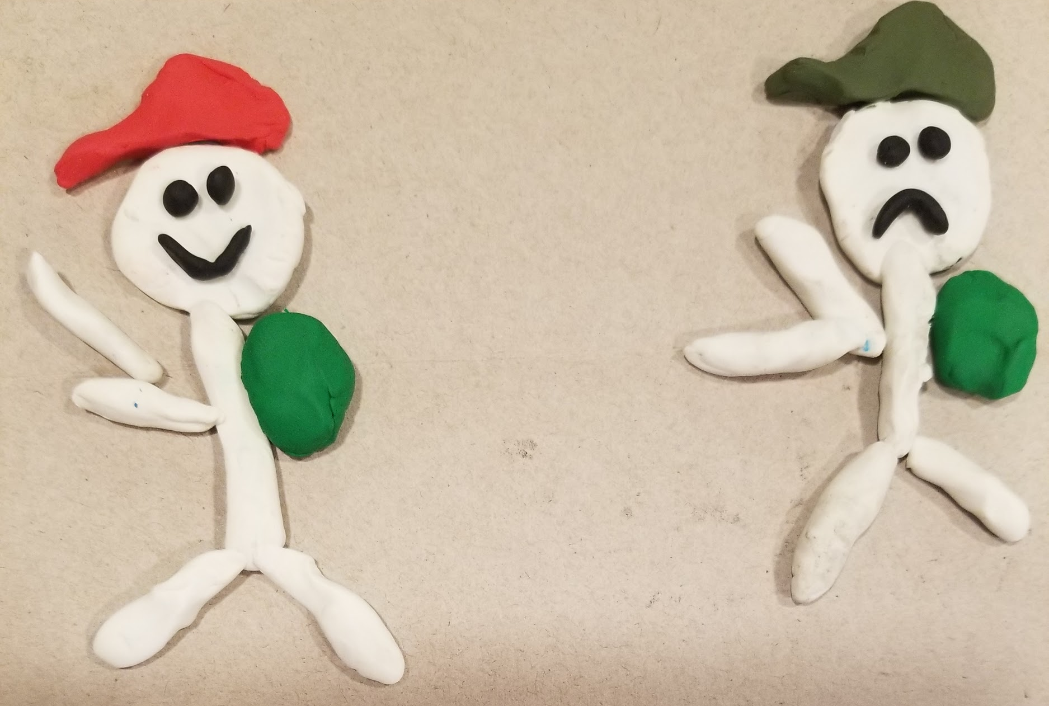 Charlie started becoming really depressed. He didn’t even want to go to school anymore.

Bob started to get really worried about his brother and wondered why Charlie was always sad?
Charlie was always sad.

One day Charlie saw a doctor and got a brain scan. This is what the scan revealed.
